INVITATION FOR BID (SALE)
UNIVERSITY OF ARKANSAS

SUBMIT BID TO: |  | Office of Business Affairs | Bid Number: | S081219
 |  | 321 Administration Building | Bid Description: | TIMBER SALE
 |  | Fayetteville, AR 72701 | Bid Opening Date: | 09/10/2019 | Time: | 2:30 P.M.
 |  | (479) 575-6400 | Inspection Date(s): | See Below
 |  | Attn: Ed Beadles
THIS OFFICIAL BIDSHEET MUST BE SIGNED AND RECEIVED IN A SEALED ENVELOPE WITH BID NUMBER AND BID OPENING DATE CLEARLY NOTED ON OUTSIDE OF ENVELOPE.

Bids may not be faxed directly to the University in response to this Invitation to Bid.
Bid will be accepted either signed in ink or electronic or facsimile signature.

NAME: |  |  |  |  | TITLE:
ADDRESS: |  |  |  |  | PHONE: _____________FAX:
 |  |  |  |  | DATE:
NAME (TYPE OR PRINT): |  |  |  |  | FEDERAL EMPLOYER I.D. #:
SIGNATURE: |  |  |  |  | OR SOCIAL SECURITY #:

ITEMS LISTED ON THE ATTACHED SHEETS WILL BE SOLD TO THE HIGHEST BIDDER
SUBJECT TO ALL TERMS AND CONDITIONS LISTED HEREIN.
STANDARD TERMS AND CONDITIONS

1. | GENERAL: Any special terms and conditions included in the Invitation for Bid override these standard terms and conditions. The standard terms and conditions and any special terms and conditions become part of any contract entered into if any or all parts of the bid are accepted by the University of Arkansas.
2. | ACCEPTANCE AND REJECTION: The University reserves the right to accept or reject all or any part of a bid or any and all bids, to waive minor technicalities, and to award the bid to best serve the interest of the University.
3. | PRICES: Bid unit price. In case of errors in extension, unit prices will govern. Prices are firm and not subject to escalation unless otherwise specified in the Invitation for Bid. Unless otherwise specified, the bid must be firm for acceptance for thirty (30) days from the bid opening date.
4. | AMENDMENTS: The bid cannot be altered or amended after the bid opening date except as permitted by regulation.
5. | AWARD: Award will be on either a per item or an all or none basis, whichever is more advantageous to the University.
6. | PATENTS OR COPYRIGHTS: The contractor agrees to indemnify and hold the University harmless from all claims, damages and costs, including attorneys’ fees, arising from infringement of patents or copyrights.
7. | ASSIGNMENT: Any contract entered into pursuant to this Invitation for Bid is not assignable nor the duties thereunder delegable by either party without the written consent of the other party of the contract.
8. | INSPECTION: The bidder is invited, urged and cautioned to inspect property to be sold prior to submitting a bid. Property will be available for inspection at the place and times specified in the Invitation For Bid. In no case will failure to inspect constitute grounds for withdrawal of a bid after opening. Deficiencies, when known, have been indicated in the item description. However, absence of any indicated deficiency does not mean the item may not have deficiencies. Any oral statement or representation by any representative of the University is unauthorized and shall confer no right upon the Bidder or Purchaser. Withdrawal of a bid must be made before the bid opening time, in writing and presented to the above Buyer.
9. | CONDITION OF PROPERTY: Unless otherwise specifically provided in the Invitation For Bid, all property is offered for sale “as is, where is.” The description is based on the best available information. However, the University makes no warranty, expressed or implied, as to quality, kind, character, quantity, weight, size or description of any of the property or its fitness for any use or function.
10. | WEIGHING: Where weighing is necessary to determine the exact purchase price hereunder, the purchaser shall arrange for and pay all expenses of weighing material.
11. | PAYMENT: The purchaser agrees, upon notification, to pay for the item(s) awarded to him/her in accordance with the prices quoted in his/her bid. Payment is to be made in the form of cashier’s check, certified check, or bank draft.
12. | TITLE: Unless otherwise specified in the Invitation For Bid, title to the items or property sold hereunder shall vest in the purchaser when full payment is made.
13. | REMOVAL OF PROPERTY: Unless otherwise specified in the Invitation For Bid, the purchaser shall be entitled to obtain the property upon vesting of title or the receipt of payment for the property to him/her. The purchaser shall remove the property at his/her expense. In no way will the University of Arkansas suffer any expense, penalty, personal or property liability in the removal of said equipment.
14. | STATE SALES AND/OR USE TAX: Purchaser of personal property from the University of Arkansas may be subject to the payment of a state sales and/or use tax. The University of Arkansas is not responsible for collection of state tax.
15. | SPECIAL NOTICE: Failure to respond to three (3) consecutive Invitations For Bid or notices of bid shall be considered sufficient cause to remove your name from the bidder’s list.
16. | CONTRACT WITH THE UNIVERSITY: A signed Invitation For Bid constitutes a contract with the University of Arkansas to pay the amount indicated for the equipment/items offered for sale. Failure to comply could result in action being taken by the Attorney General’s Office and/or be cause for rejection of all future bids. Unsigned bids will not be read or considered. By signing the contract the bidder warrants that they are not under eighteen (18) years of age. Employees of the Department of Finance and Administration, State of Arkansas, may not bid.
17. | DISPUTES: Except as otherwise provided in this contract, any dispute concerning a question of fact arising under this contract which is not disposed of by agreement, shall be decided by the Business Manager. Tie bids will be determined by a flip of a coin by the staff of the University’ Purchasing Department.
18. | OTHER REMEDIES: In addition to the remedies outlined herein, the contractor and the University have the right to pursue any other remedy permitted by law or in equity.

Time of Performance

Time is of the essence in the rendering of services hereunder. Proposer agrees to perform all obligations and rendering of services set forth in this IFB.

Contracting Authority

Contractor shall perform all services as an independent Contractor and shall discharge all of its liabilities as such. No acts performed, or representation made, whether written or oral, by Contractor with respect to Third Parties shall be binding to the University.

Default
In the event that the Proposer fails to carry out or comply with any of the Terms and Conditions of the contract with the University, the University may notify the Proposer of such failure or default in writing and demand that the failure or default be remedied within ten (10) working days; and in the event the Proposer fails to remedy such failure or default within the ten (10) working day period, the University shall have the right to cancel the contract upon thirty (30) days written notice.

The cancellation of the contract, under any circumstances whatsoever, shall not affect or relieve Proposer from any obligation or
liability that may have been incurred or will be incurred pursuant to the contract and such cancellation by the University shall not limit
any other right or remedy available to the University by law or in equity.

Qualifications of Bidder

The University may make such investigations as it deems necessary to determine the ability of the bidder to meet all order and delivery requirements as stated herein and the bidder shall furnish to the University all such information and data for this purpose that the University may request. The University reserves the right to reject any bid if the evidence submitted by, or investigations of, such bidder fails to satisfy the University that such bidder is properly qualified to carry out the obligations of the Agreement.

Indemnification

Contractor agrees to indemnify and hold harmless the University and its officers and employees from any claim, damage, liability, injury, expense, or loss, including defense cost and attorney’s fees arising out of Contractor’s performance under this Agreement or as a consequence of the existence of this Agreement.

Permits and Licenses

Contractor shall, at its sole expense, procure and keep in effect all necessary permits and licenses required for its performance under this Agreement, and shall post or display in a prominent place such permits and/or notices as are required by law.

Termination

In the event that the Contractor shall fail to maintain or keep in force any of the terms and conditions of the Contract, the University may notify the vendor in writing of such failure and demand that the same be remedied within Ten (10) days. Should the Contractor fail to remedy the same within said period, the University shall then have the right to terminate the Contract by giving the Contractor thirty (30) days written notice.

Right to Audit

At any time during the term of the agreement and for a period of four (4) years thereafter the University duly authorized audit representative, at its expense and at the reasonable times, reserves the right to incrementally audit Proposer’s records and manufacturer’s pricing relevant to all pricing provided under this agreement. In the event such an audit by the University reveals any error/overpayments, the Proposer shall refund the University the full amount of such overpayments within thirty (30) days of such audit findings, or the University at its option, reserves the right to deduct such amounts plus interest owing the University from any payments due Seller.

Acceptance of Products and Services

All products furnished, and all services performed under this agreement shall be to the satisfaction of the University and in accordance with the specifications, terms, and conditions of the agreement. The University reserves the right to inspect the products furnished or the services performed, and to determine the quality, acceptability, and fitness of such products or services.

Severability

If one or more provisions of the resultant agreement, or the application of any provision to any party or circumstance is held invalid, unenforceable, or illegal in any respect, the remainder of the agreement and the application of the provision to other parties or circumstances shall remain valid and in full force and effect.

Non-Waiver of Defaults

Any failure of the University at any time, to enforce or require the strict keeping and performance of any of the terms and conditions of this agreement shall not constitute a waiver of such terms, conditions, or rights, and shall not affect or impair same, or the right of the University at any time to avail itself of same.

Governing Law

This agreement shall be construed and governed by the laws of the State of Arkansas.

SEE NEXT PAGE

INVITATION TO BID ON HARDWOOD AND PINE TIMBER

University of Arkansas – Division of Agriculture

Livestock and Forestry Research Station

Batesville, Independence County, Arkansas

River Hills – September 2019

SUMMARY:

Seller: University of Arkansas

Timber for Sale: Oak and other Hardwood Sawtimber
Mixed Hardwood and Pine Pulpwood and Pine Sawtimber

Location: Livestock and Forestry Research Station, Independence County, Arkansas, west of Batesville

Sale/payment type: Per piece basis, pay as cut

Bid deadline: Tuesday September 10, 2019.

PLEASE NOTE: 1) ENDANGERED SPECIES RESTRICTIONS – see SECTION IV
2) ALL BMPs MUST BE IMPLEMENTED AS REQUIRED – see SECTIONS VIII and XIX

Contract period: about 22 months, ending no later than June 15, 2021 (No harvesting from June 15th through September 15th, any year.)

Acres in sale area: approximately 317.9 acres

Volume estimate*: Oak sawtimber 953.12 MBF (Doyle) 7,628 tons
Other Hardwood sawtimber 392.25 MBF (Doyle) 3,138 tons
Hardwood pulpwood 708 cords 2,124 tons
Pine pulpwood 9 cords 27 tons
Pine Sawtimber 13.8 MBF (Doyle) 107 tons

* conversions based on Arkansas Severance Tax Law
BID:

Sawtimber – Oak $ per ton ______________ OR $ per MBF (Doyle) _____________
Sawtimber – Other Hardwood $ per ton ______________ OR $ per MBF (Doyle) _____________
Pulpwood – Hardwood $ per ton ______________ OR $ per cord ______________

Pulpwood – Pine $ per ton ______________ OR $ per cord ______________

Sawtimber- Pine $ per ton_______________ OR $ per MBF (Doyle) ________________

Bidder name: _____________________________________________ Phone no. ____________________________

The University of Arkansas (Seller) is offering for sale to the highest bidder (Buyer), pine, oak, and other hardwood sawtimber, and pine and mixed hardwood pulpwood, located in the River Hills tracts, Livestock and Forestry Research Station, west of Batesville, Arkansas on Highway #106. Bids ($ per ton or MBF) should be submitted for all the marked and designated timber within the sale area. Payment will be made on a per piece basis as cut. Submit bids by 2:00 pm., Tuesday, September 10, 2019, to:

University of Arkansas
Office of Business Affairs
321 Administration Building
Fayetteville, Arkansas 72701
479-575-6400

Attn: Ed Beadles

Following is a prospectus of information and conditions for bid and sale. Further information may be obtained from: Mr. Michael McGowan, Station Forester, 70 Experiment Station Road, Batesville, AR 72501 or Mr. Don Hubbell, Director, Livestock and Forestry Research Station, University of Arkansas, 70 Experiment Station Drive, Batesville, AR 72501, (870) 793-7432, prior to submission of bid.

I. LOCATION: The timber is located on the University of Arkansas Livestock and Forestry Research Station in Independence County. The Livestock and Forestry Research Station main office can be located by going west from Batesville on Hwy 69 approximately 8 miles, then south on Hwy 106 approximately 3 miles. The harvest area is located in the River Hills tract, about 4.5 miles west of the main station office. The timber is contained in four (4) harvest blocks totaling about 317.9 acres, as shown on the attached maps. The perimeter of the harvest area is marked by woods roads, pastures, fences, and/or with pink “Timber Harvest Boundary” flagging. Access to the harvest area is by existing woods roads. The harvest blocks are located in Sections 4, T 13 N, R 8 W, and Sections 27, 28, and 34, T 14 N, R 8 W. Bids ($ per ton or MBF or cord) must be submitted for the entire sale area.

- ESTIMATE OF VOLUME: A summary of the estimated timber volume is provided. However, each bidder is expected to make their own cruise and make their bid based on their own volume estimate. There is no representation or guarantee by the Seller as to the volume of timber that has been designated for removal. The volumes (based on sample plots) were estimated by measuring the diameter of each sample tree at breast height (DBH), then calculating board foot volume based on DBH and average merchantable log height (16 ft) for sawtimber, and cordwood volume based on DBH and stick height (8 ft) for pulpwood. Total volume of the sale is estimated as follows*:

Oak sawtimber 953.12 MBF (Doyle) 7,628 tons
Other Hardwood sawtimber 392.25 MBF (Doyle) 3,138 tons
Hardwood pulpwood 708 cords 2,124 tons
Pine pulpwood 9 cords 27 tons
Pine Sawtimber 13.8 MBF (Doyle) 107 tons

NOTE: Volume estimates do not include topwood.

*Conversion factors to be used for comparisons (based on Arkansas Severance Tax Law):

Hardwood sawtimber 8.0 tons/MBF Doyle
Pine pulpwood 3.0 tons/cord
Hardwood pulpwood 3.0 tons/cord

A tree tally (diameter distribution) based on the sample plots is attached to this bid prospectus. More detailed stand information may be obtained from Mr. Don Hubbell, Director, or Mr. Michael McGowan, Forestry Program Technician II, RF# 1494, Livestock and Forestry Research Station, University of Arkansas, 70 Experiment Station Drive, Batesville, AR 72501, (870) 793-7432.

- CUTTING PROCEDURES: Cutting order of stands- Timber in River Hills (RH) Stands 1,2,3,9 and 6 (approximately 92 acres) must be harvested first. Timber from stands RH 20, 33, 34 and 35 included in this bid packet may not be harvested until harvesting is completed in RH Stands 1,2,3,9 and 6, and meets with Station Director/Forester’s approval for research plot work. In Stands 1, 2, 3, 9, 6, and 20, all trees marked with orange paint must be felled.

- All merchantable trees in the harvest areas must be felled (clearcut or shelterwood final removal – remove all trees). The perimeter of the harvest area is marked by woods roads, pastures, fences, and/or with pink “Timber Harvest Boundary” flagging. Access roads and loading/decking sites must be agreed to by the Seller and Buyer. As much as possible, use existing woods roads.

Care must be taken to prevent excessive damage to the residual trees surrounding the harvest area. The Buyer will be assessed a penalty of double average stumpage value, determined by the Seller, for excessive damage to any sawtimber trees (greater than 13 inches DBH) during felling or transporting activities. The same penalty will apply to any undesignated trees that are cut. Stumps of trees cut shall be no higher than 12 inches above average ground line, except for those trees with wire, nails, visible defect, or excessive flare that necessitates cutting a stump higher than 12 inches.

Follow all Best Management Practices (BMPs, see Sections VIII and XIX). Care must be taken to prevent damage to stream beds and stream banks. Minimize equipment access wherever possible. Restore the access roads and stream crossings after harvest completion.

ENDANGERED SPECIES: The U.S. Fish and Wildlife Service has determined that known endangered species sites occur close to the Livestock and Forestry Research Station, and the species’ habitats may include station forests. Harvesting restrictions must be followed. No harvesting is allowed from June 15th through September 15th, any year.

- FENCES, ROADS, GATES, ETC.: All current roads must be kept usable, and free of debris. The Buyer agrees to repair, at his own expense, damage caused by his operation to fences, roads, gates, bridges and culverts. The Buyer agrees to close out, at his own expense, any temporary roads or trails built for the extraction of the timber, including the cost of returning any trail to grade, water bars, and water turnouts. The Buyer may deck extracted timber outside the harvest block only in areas designated by Station personnel for that purpose. All logging debris must be returned to the cut area. Any old fences found within the perimeter of the stands to be harvested may be destroyed.

- ACCESS and SUPERVISION: The Buyer and his agents shall have normal access on and across the property for the purpose of conducting harvesting operations during the time frame of this agreement. The Buyer must designate an on-site supervisor. The Seller reserves the right to check cutting operations at any time to determine whether or not the provisions of this agreement are being carried out. The Buyer or their agents are not employees of the Seller, but are independent contractors.

- WET PERIODS: If the condition of the ground during wet periods results in rutting greater than 6 inches in depth in the woods, or road damage is determined objectionable by the Station Director and/or the University Forester, the Buyer may be asked to suspend cutting and hauling activities. Down time due to wet ground conditions and requested by the Station Director is not chargeable to, and will be added to the end of the term of the contract. Down time not requested by the Station Director is chargeable to the term of the contract and will not be added to the ending dates.

- BEST MANAGEMENT PRACTICES: The Buyer will in all respects observe and follow all Arkansas Best Management Practice guidelines as applicable, and as explained in the Arkansas Forestry Commission’s “Arkansas Forestry Best Management Practices for Water Quality Protection” booklet (available on-line at http://www.forestry.state.ar.us/bmp/bmpbookrevise.pdf). These include, but are not limited to:

1. Observe, and restrict activities in, streamside management zones (SMZs).
2. Streams should be crossed at right angles, using bridges, culverts, low water fords (stone), or other suitable materials.
3. Use wing ditches, broad-based dips, rolling dips, crowning, and diversion ditches to maintain good road drainage.
4. Harvest site landings should be located away from streams and SMZs on fairly level ground.
5. Skid trails should follow contours as much as possible.
6. Temporary stream/slough crossings must be restored to original condition prior to harvest closeout.
7. See also Section XIX – proper seeding, installation of water bars, etc.

Proper BMPs must be in place prior to any temporary breaks (down time) in harvest activities.

- FIRE CONTROL MEASURES: The Buyer will exercise due care to prevent fires and will be responsible for control of all fires occurring in the sale area.

- CONTRACT PERIOD: The contract period will be for approximately twenty-two (22) months, starting from the date the contract is awarded, but ending no later than June 15, 2021. Any merchantable tree, or any cut forest product, within the prescribed area not removed at the termination of this agreement becomes the property of the Seller.

- INSURANCE COVERAGE: The Buyer shall maintain general liability and auto liability insurance, and Worker’s Compensation insurance as required by the State of Arkansas. Copies of certificates showing proof of insurance coverage as set below shall be filed with the University of Arkansas prior to awarding the contract. Insurance shall be maintained for the entire contract period.

1. Workers Compensation: (a) as required by the State of Arkansas.
(b) Employer’s Liability - $100,000.00 each.

2. Comprehensive General Liability: (including premises operations; independent contractor’s protective; products and completed operations; broad form property damage).

3. (a) Bodily Injury: $1,000,000.00 each occurrence, $1,000,000.00 aggregate.

(b) Property Damage: $1,000,000.00 each occurrence, $1,000,000.00 aggregate.

4. Business Automobile Liability Insurance – The Buyer shall be required to maintain automobile liability insurance and shall file certificates with the University.

Insurance policies shall be written by a company or companies authorized to do business in the State of Arkansas. The limits of liability of such insurance shall be written for not less than the following:

- Comprehensive Business Automotive Liability (including owned, non-owned and hired vehicles) with a combined single limit of $500,000.00 per occurrence.
- Medical Payments (each person) $5,000.00
- Uninsured and underinsured Motorist Coverage with a combined single limit for Bodily injury and Property damage for not less than $500,000.00 per occurrence.

5. Subcontractors: The Buyer is responsible for any subcontractors hired by the Buyer to assist with any aspects of the harvest operation. This includes, but is not limited to, felling, skidding, loading, and clean-up on the harvest site, and transporting timber from the harvest site to the mill. This requires that the Buyer maintains adequate insurance coverage, as described in Section X., to cover any subcontracted work and workers.

6. The “Board of Trustees of the University of Arkansas acting for and on behalf of the University
of Arkansas, Fayetteville” must be named as an Additional Insured.

- PERFORMANCE BOND: The Buyer will deposit $1,000 (as a performance bond) with the Seller to be held until the completion of this contract against damages caused by the operation of harvesting timber. The deposit check should be payable to ‘The University of Arkansas’ and delivered to the Station Director prior to the start of the harvest. (Mr. Don Hubbell, Director, Livestock and Forestry Research Station, University of Arkansas, 70 Experiment Station Drive, Batesville, AR 72501)

- BID FORMAT: Bids must be submitted in the following format:

Sawtimber – Oak $ per ton ______________ OR $ per MBF (Doyle) _____________
Sawtimber – Other Hardwood $ per ton ______________ OR $ per MBF (Doyle) _____________
Pulpwood – Hardwood $ per ton ______________ OR $ per cord ______________

Pulpwood – Pine $ per ton ______________ OR $ per cord ______________

Sawtimber- Pine $ per ton_______________ OR $ per MBF (Doyle) ________________

Bidder name _________________________________________ Phone no. ___________________________

Conversion factors to be used for comparisons (based on Arkansas Severance Tax Law):

Hardwood sawtimber 8.0 tons/MBF Doyle
Pine pulpwood 3.0 tons/cord
Hardwood pulpwood 3.0 tons/cord

The right to reject any and all bids is reserved.

- PAYMENT: Bid price ($ per ton or MBF) will cover all timber designated for sale within the identified sale areas. Payment will be made on a per piece basis as cut. A copy of the scaler’s tally sheets/ weight tickets must accompany each settlement to verify each payment. Settlement is due weekly for the loads delivered the previous week. The settlement period ends on Sunday of each week. Payment must be by cashier’s check payable to “The University of Arkansas”. Payment should be mailed to Mr. Don Hubbell, Director, Livestock and Forestry Research Station, University of Arkansas, 70 Experiment Station Drive, Batesville, AR 72501, (870) 793-7432. The Buyer is responsible for any severance taxes.

- COUNTY, STATE and FEDERAL LAWS: The Buyer agrees to comply with all applicable County, State and Federal laws during the completion of this contract.

- TITLE: Title to and responsibility for the trees shall pass to the Buyer as they are severed from the stump, but the Seller retains and the buyer grants a vendor’s lien on all forest products cut or removed from the property until paid in full.

- The Seller is free from responsibility for any injury, death or property damage caused by the Buyer’s logging operation during the tenure of this agreement.

- RECORDS: Buyer will supply the Seller with legible copies of weight or scale tickets for all products removed.

- HARVEST CLOSEOUT: Before harvest completion, the Buyer (harvest operator) must contact and meet with the Station Director and/or University Forester prior to leaving the harvest site so that a final closeout inspection can be conducted. Unless other arrangements are made in advance, the final closeout inspection must be conducted within two (2) weeks of the last load leaving the sale site. All closeout activities must be completed within four (4) weeks of the inspection. Items to be examined include but are not limited to:

- Smooth roads, skid trails, and log landings as possible (no deep ruts or high
    - debris piles).
- Restore the access road and stream crossing after harvest completion.
- Temporary and inactive roads should have properly constructed water bars in place.
- All logging debris must be removed from streams/sloughs.
- Clean out ditches along public roads to original condition.
    - 6. Revegetate (use appropriate seed) landings and skid trails as appropriate after harvest completion.
- Clean up and haul litter, such as oil cans, grease containers, etc.
- Buyer waives all claim to above described trees located on the above described
    - property after final harvest closeout determined by Station Director.

Volume Summary (based on sample plots)

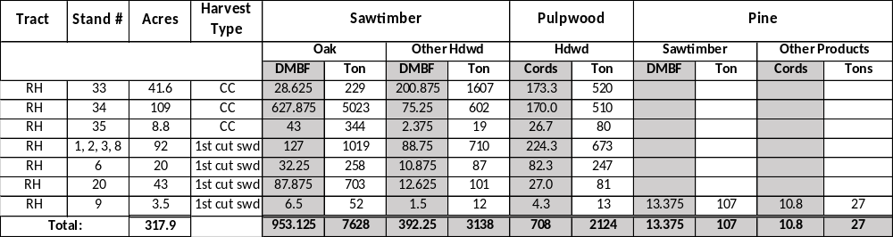

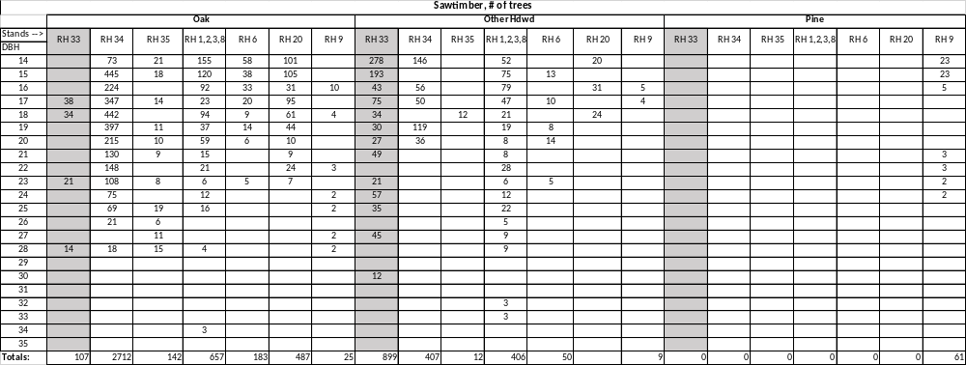
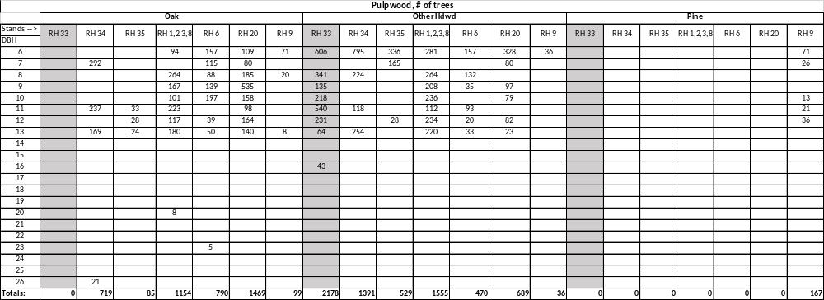

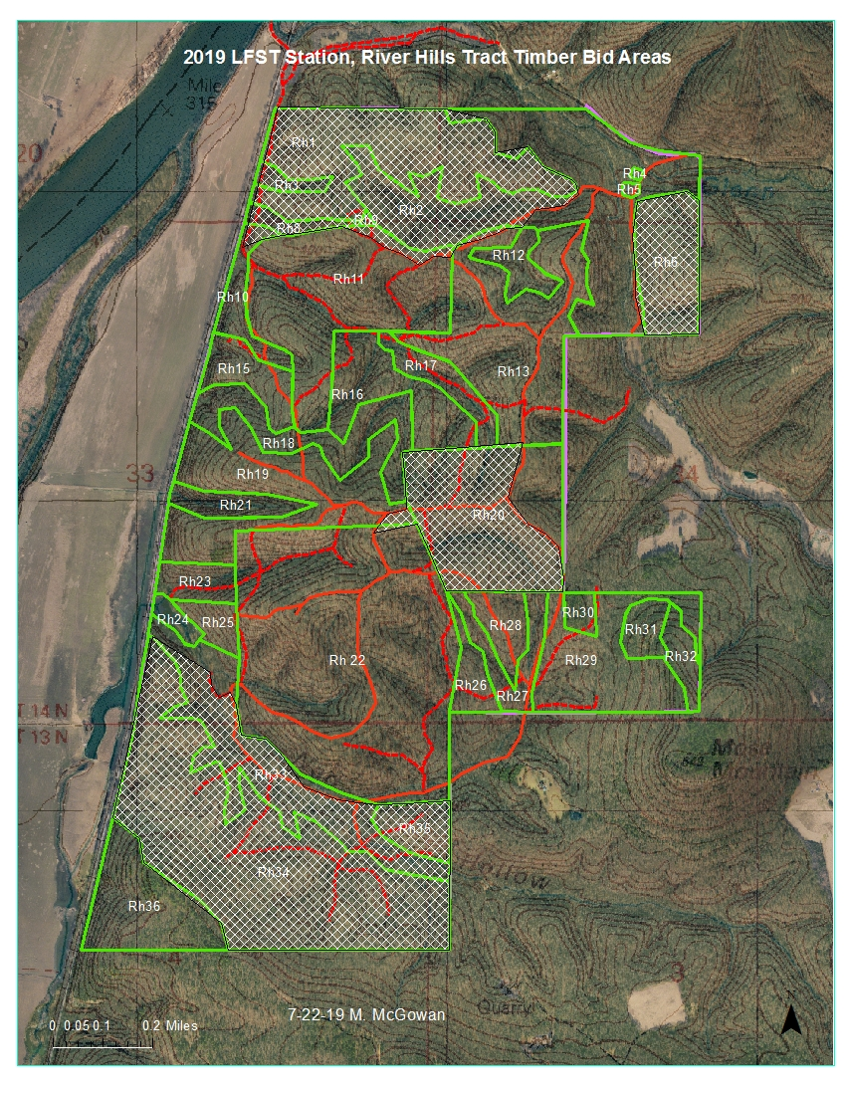

Equal Opportunity Policy Disclaimer

ATTENTION BIDDERS

Act 2157 of 2005 of the Arkansas Regular Legislative Session requires that any business or person bidding, who is responding to a formal bid request, Request for Qualifications or qualifications, or negotiating a contract with the state for professional or consultant services, submit their most current equal opportunity policy (EO Policy).

Although bidders are encouraged to have a viable equal opportunity policy, a written response stating the bidder does not have such an EO Policy will be considered that bidder’s response and will be acceptable in complying with the requirement of Act 2157.

Submitting the EO Policy is a one-time requirement. The University of Arkansas, Fayetteville Procurement Department, will maintain a database of policies or written responses received from all bidders.

Note: This is a mandatory requirement when submitting an offer as described above.

Please complete and return this form with your bid response.

Should you have any questions regarding this requirement, please contact this office by calling (479) 575-2551.

Sincerely,

Andy Fletcher

Andy Fletcher, APO, CPPO, CPPB
Manager of Procurement Services
University of Arkansas

To be completed by business or person submitting response: (check appropriate box)

____ EO Policy Attached

____ EO Policy previously submitted to Procurement Department

____ EO Policy is not available from business or person

Company Name
Or Individual: __________________________________________________________

Title: _____________________________________Date: ______________________

Signature: ____________________________________________________________
UNIVERSITY OF ARKANSAS
PROCUREMENT DEPARTMENT
1125 W. Maple ADMIN 321
Fayetteville, AR 72701
Tel: 479-575-2551
Fax: 479-575-4158

Act 157 of 2007 of the Arkansas Regular Legislative Session requires that any contractor, business or individual, having a public contract with a state agency for professional services, technical and general services, or any category of construction, in which the with the total dollar value of the contract is $25,000 or greater must certify, prior to the award of the contract, that they do not employ or contract with any illegal immigrants.

For purposes of this requirement, “Illegal immigrants” means any person not a citizen of the United States who has:

- Entered the United States in violation of the Federal Immigration and Naturalization Act or regulations issued the act;
- Legally entered but without the right to be employed in the United States; or
- Legally entered subject to a time limit but has remained illegally after expiration of the time limit.

This is a mandatory requirement. Failure to certify will result in our inability to issue a Purchase Order or Contract to you or your company.

Bidders shall certify online at http://www.arkansas.gov/dfa/procurement/pro_immigrant.html
Click on: “Procurement” on left-side information bar
Click on: Illegal Immigrant Reporting
Click on: “Vendor” Illegal Immigrant Contracting Disclosure Reporting Screen
Click on: “Vendor Submit Disclosure Form” to complete all fields required for the certification – then indicate below and sign this form to submit with your bid. ***NOTE*** Bid Number field is applicable if known.
REQUIRED: Print Screenshot and include with your proposal and/or contract.

If you have any questions, please call the UA Procurement Department at 479-575-2551.

Thank you.
Andy Fletcher
Andy Fletcher, APO
Manager of Procurement Services
University of Arkansas

**********************************************************************************************
TO BE COMPLETED BY BUSINESS OR PERSON SUBMITTING BID RESPONSE OR CONTRACT:

Please check the appropriate statement below:

_______ We certified that we are not an illegal immigrant
or do not employ or contract with any illegal immigrants.

Date of certification: ________________________

_______ We cannot so certify at this time, and we understand that
a contract cannot be awarded until we have done so.

Reason for non-certification: ______________________________

Name of Company: ___________________________________________

Signature: ___________________________________________

Name & Title: ___________________________________________
(Printed or typed)
Date: ___________________________________________




