**Q&A #4**

**RFP #681360**

**University Housing Cleaning Support**

1. Question:

What are the responsibilities across the Duncan locations? Move outs only? 1 per year?

Answer:

Responsibilities across Duncan Apartments during the year center on daily cleaning of the front office, entry, community spaces on lower and upper floor, bathrooms and small kitchen space. Throughout the year we would expect cleaning of apartments/rooms vacated by departing residents…generally few during the semester, a potential 3% melt over winter break and then of course full flipping of rooms/apartments upon move out at the end of the academic years.

1. Question:

Locations with frequency labeled as “weekends” are only cleaned during the weekend correct?

Answer:

Weekend cleaning is expected to be general cleaning to ensure tidiness and operations i.e., trash pulling from collection areas and chutes to prevent backups, restocking of paper products and cleanup of any messes found within bathrooms, hallways, community spaces on each floor of the buildings listed, our towers:

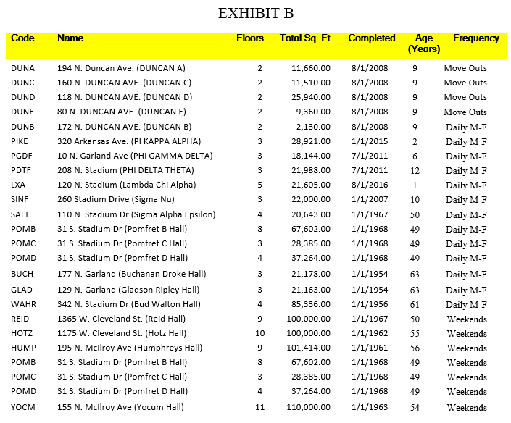

1. Question:

The RFP states 138,250 Gross SF. What’s the total SQF of all locations your proposing?

Answer:

Exhibit B breaks it down by building:

