321 Administration Building, Fayetteville, Arkansas 72701
Phone: 479.575.2551 Fax: 479.575.4158

MEMORANDUM

TO: All Bidders

FROM: Ellen Ferguson
Procurement Coordinator

DATE: March 7, 2018

RE: Final Scoring Summary for RFP #171129, Arbitrage Services

In response to a bidder’s question regarding the scoring summary for the above listed RFP, a revised scoring sheet has been calculated.

The evaluation committee made every effort to consistently evaluate each proposal. Upon review, an inconsistency was discovered resulting in a miscalculation. This changed the proposal order ranking as shown below, but did not change the top ranking and resulting award to FirstSouthwest Asset Management.

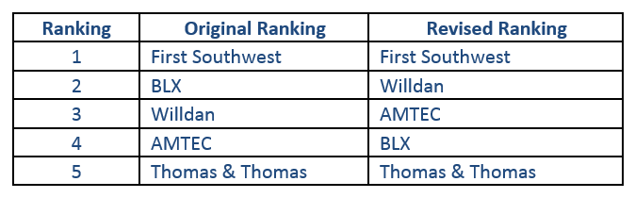

The revised final scoring summary has been fully reviewed and verified, and is posted on HogBid following this document. The University of Arkansas wishes to thank all bidders for their participation in this RFP.

