Questions regarding the University of Arkansas helium recovery system for the NMR facility in the Chemistry and Biochemistry Research Building.
- Item 2 on the bid includes the plumbing of helium lines from the NMR’s to the recovery room. Unfortunately, some vendors do not provide this. Typically, the piping is contracted to a plumbing company or completed internally by university’s facility department. Is the plumbing a necessary component that must be provided by the vendor, or can this be split and contracted out by another company? To reiterate, some vendors are a manufacturing company that produces mechanical equipment, including all components of the helium recovery system from the recovery bag to liquefier.

Answer: For installing plumbing form the magnet to the recovery system, vendor will install or contract out other contractors to make sure meet the vendor's requirement, site preparation and finish on time. The installers will need to be aware the safety of working around the high magnetic field. The installation includes materials and labors.

- How far is the planned recovery room from the NMR lab?

Answer: Please reference the attachment of room layout (Below).

- Please confirm that a 250L transfer Dewar is to be included with the sytem. Are there any specific options requested for that? Options include, but are not limited to Locking casters, (Two wing style locks), Electric pressure builder (Dual set pt.), Differential pressure liquid level gauge, Superconducting level system, and Built-in VJ Withdrawal System.

Answer: If the vendor could provide the transfer Dewar, vendor will include 250 Liters magnet safe Dewar with two swivel locking casters (wing Nut or Pedal Locking), pull handle, differential pressure liquid level gauge, and Electric Pressure Building system NOT required.

NMR lab Layout and Planned Recovery Equipment Room
- Hall way, NMR labs and planned equipment room
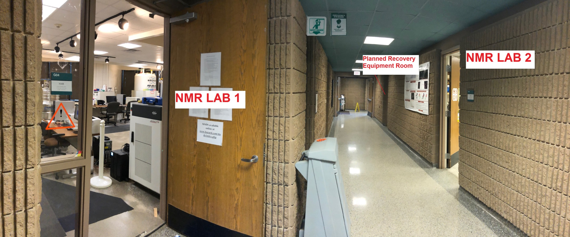
Note: Planned Recovery Equipment Room is next to NMR lab 2. The hall way is 7 feet wide. The plumbing will run from total of 7 magnets, 5 magnets are located at NMR Lab 1, and 2 magnets are located at NMR Lab 2.

- Inside Planned Recovery Equipment Room
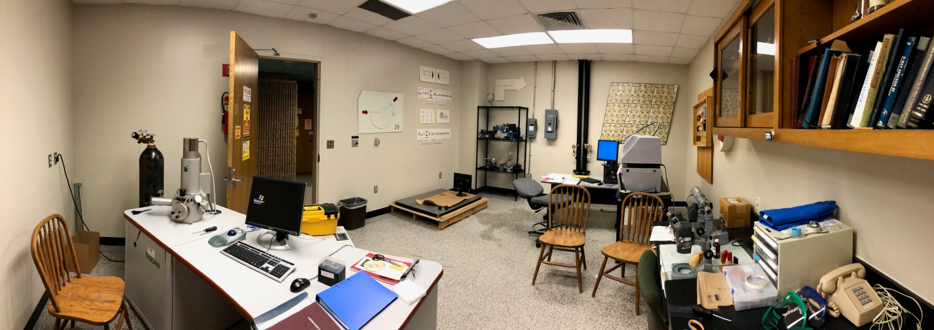
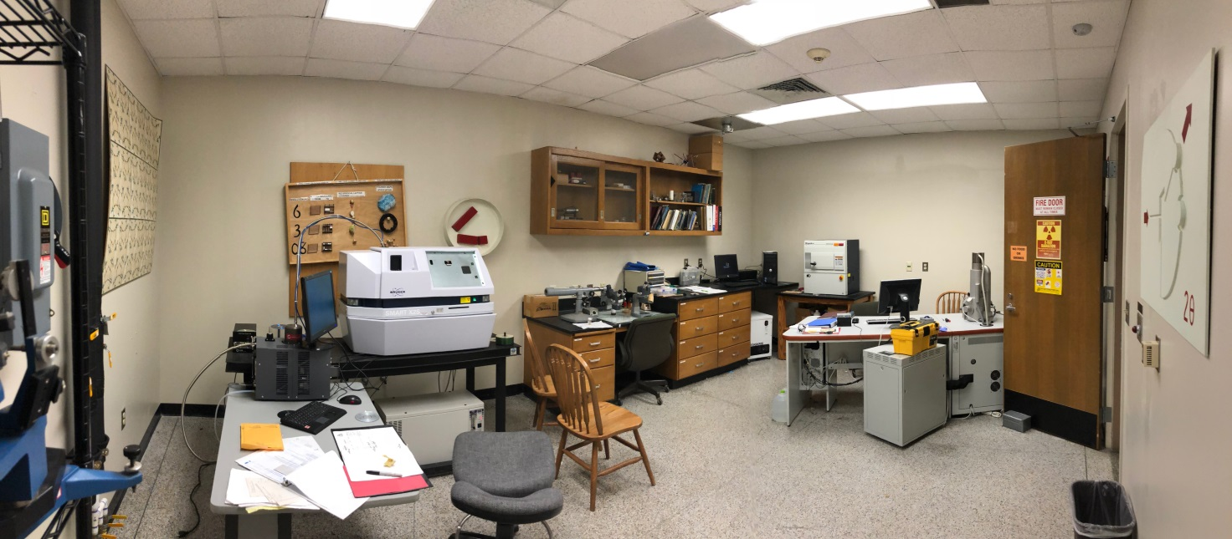
Note: The room is 22’ X 18’ with 8’ 10” ceiling height. 3 Phase, 208V, 20 A, and 100A Breakers, 1 Phase 20 A, 120V outlets and Chill water available.
- NMR Lab 2 From the entrance door
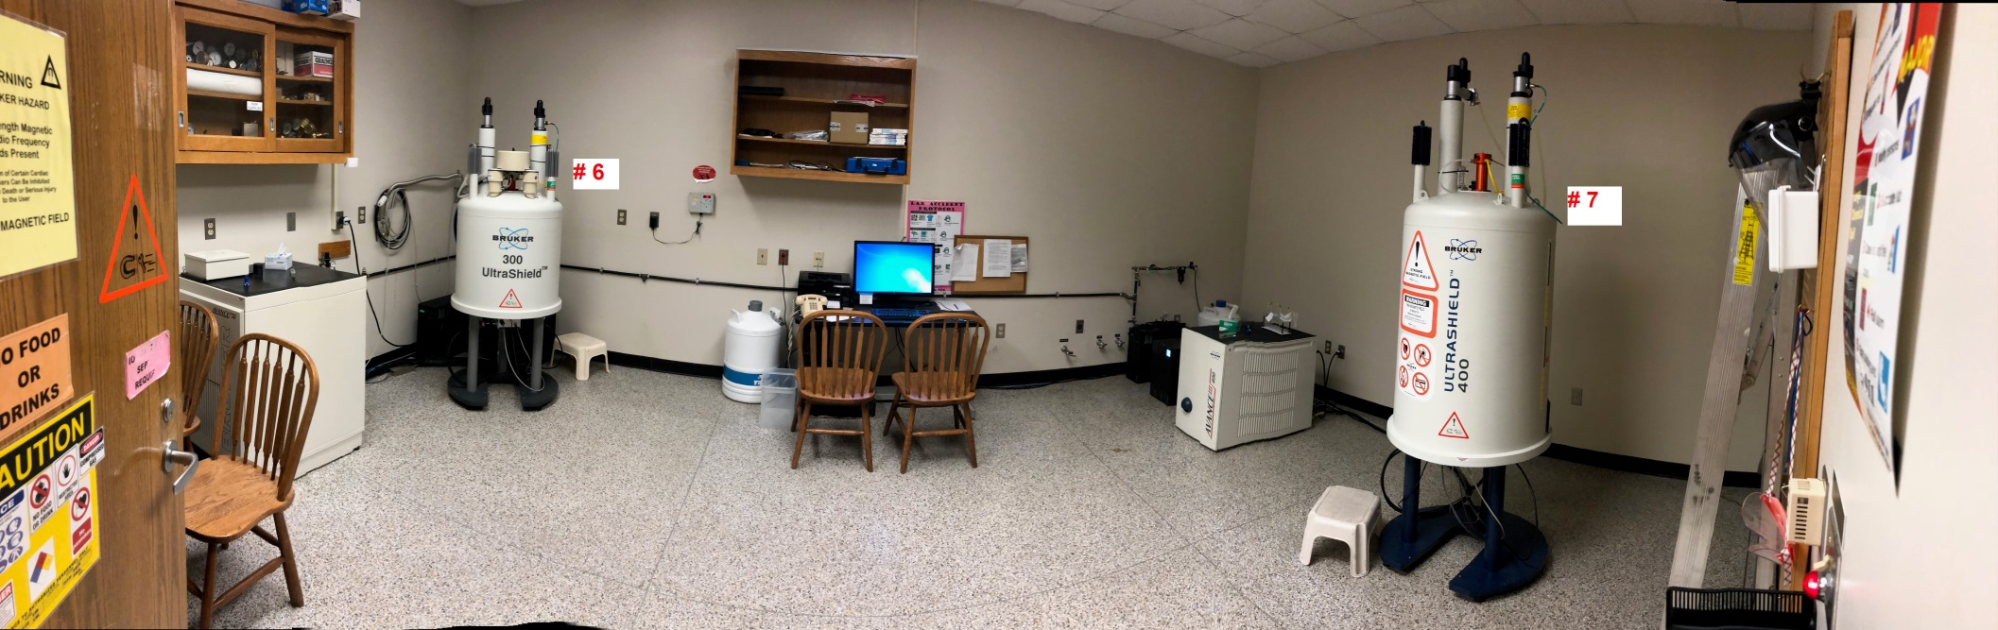
Note: Magnets are numbered #6 and #7. The magnets are approximately 17’ apart. The room size is 22’ x 14’ with 8’ 10” ceiling height.

- NMR Lab 2, view from the corner.
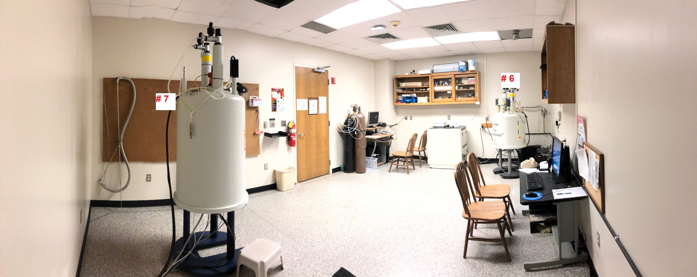

- NMR Lab 1, view from the entrance door
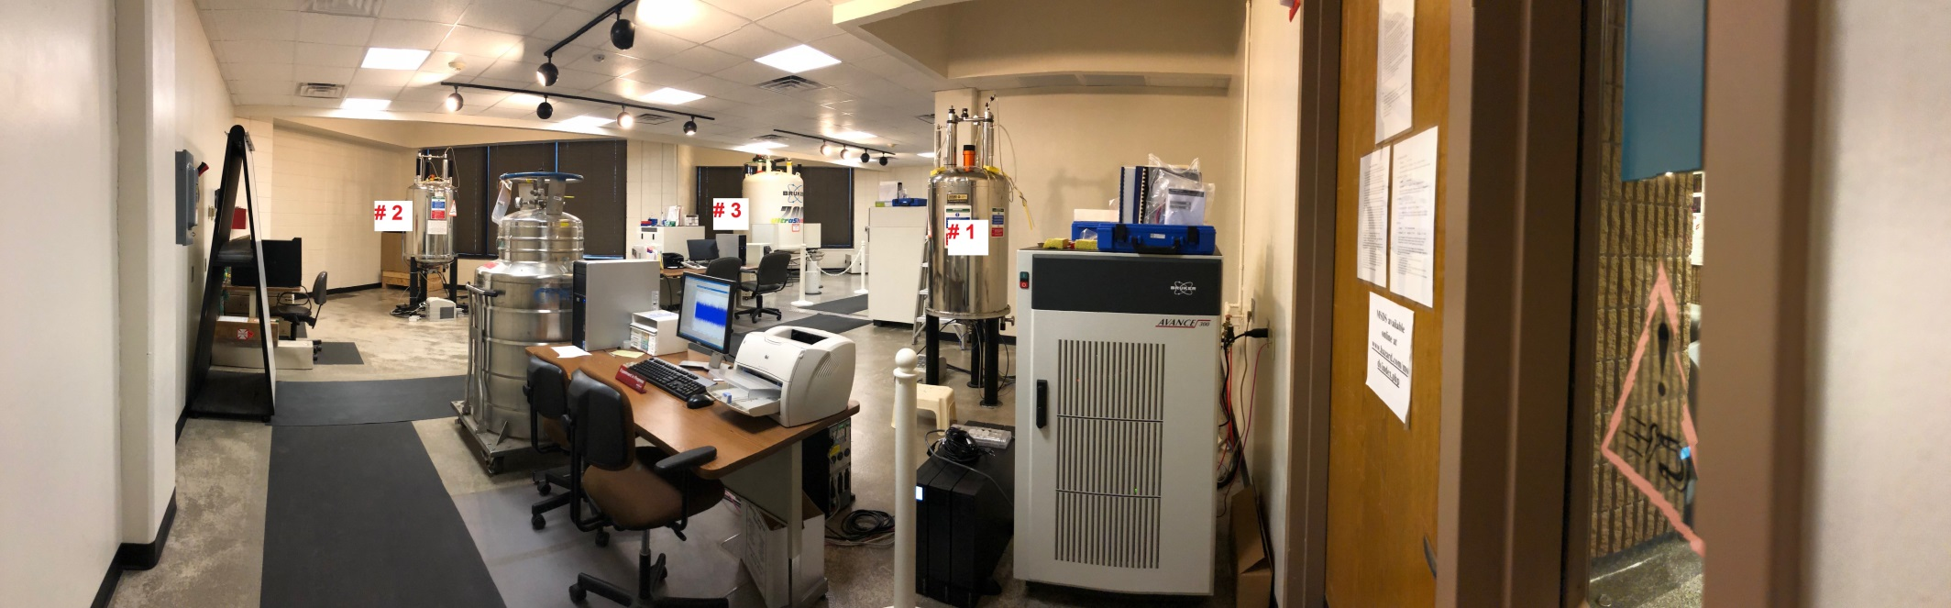
Note: Magnets are numbered start with the #1 at the right, once entering from the entrance and counting clockwise. The distance between magnet # 1 and #2 is approximately 18’. The distance of magnet #2 and #3 is approximately 23’. Magnet #2 and #3 are installed at the area of Right Triangle space. The brick wall and glass wall behind #2 and #3 formed two sides of 90 degree angle of the triangle and the length of each side is approximately 16’.

- NMR Lab 1, view from the corner.
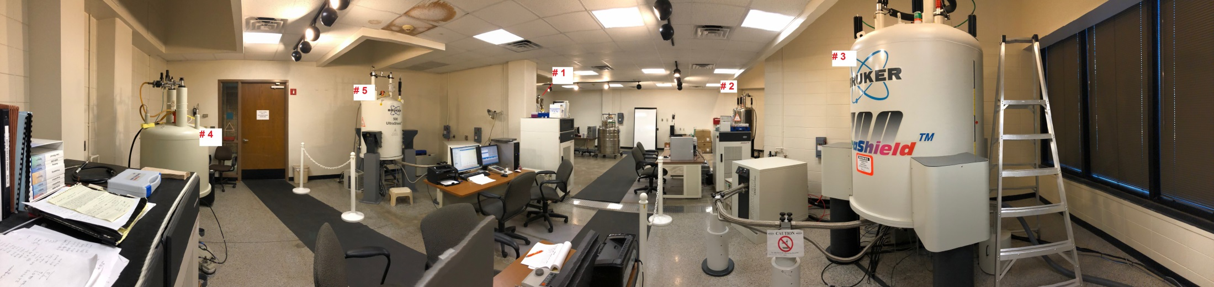
Note: The distance between magnet #3 and #4 is 20’, and #4 and #5 is 12’. The room size is 25’ x 42’ without include two Right Triangle Space. The door between #4 and #5 is the exit door.

- NMR Lab 1, view from the middle of the room
