U N IVE RS I TY OF

ARKAN SAS
321 Administration Building, Fayetteville, Arkansas 72701
Phone: 479.575.2551 Fax: 479.575.4158
October 24, 2017
RE: Intent to Award — INVITATION FOR BID (IFB) #R654045
To All Respondents:
The University of Arkansas Procurement Division has received official recommendation of award for the Uniform Apparel & Accessories Services — Invitation For Bid #R654045 The recommendation for award extends to Clean Uniform.
Respectfully, this letter of "Intent to Award" serves as notification that contract negotiations will commence with the successful vendor with the ultimate goal of a Purchase Order/Contract to be issued by the University of Arkansas.
The University of Arkansas is thankful for the attention of each respondent, and for the time and effort expended in responding to the IFB. We encourage and appreciate the participation of our vendor community. Thank you for your interest and participation.
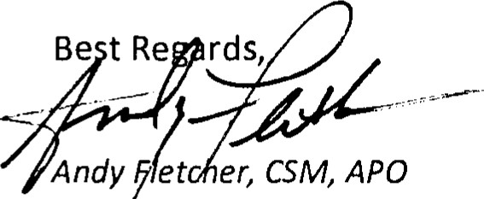Andy et er, CSM, APO Procurement Manager &
Project Specialist for Science and Research
Business Services
University of Arkansas — Fayetteville
479.575.6761

