UNIVERSITY OF

ARKANSAS
321 Administration Building, Fayetteville, Arkansas 72701
Phone: 479.575.2551 Fax: 479.575.4158
June 26, 2017
RE: Intent to Award - REQUEST FOR PROPOSAL (RFP) #R634413
To All Respondents:
The University of Arkansas Procurement Division has received official recommendation of award for the WATER TREATMENT PROGRAM - REQUEST FOR PROPOSAL #R634413. The recommendation for award extends to Chem-Aquae Inc.
Respectfully, this letter of "Intent to Award" serves as notification that contract negotiations will commence with the successful vendor with the ultimate goal of a Purchase Order/Contract to be issued by the University of Arkansas.
The University of Arkansas is thankful for the attention of each respondent, and for the time and effort expended in responding to the RFP. We encourage and appreciate the participation of our vendor community. Thank you for your interest and participation.
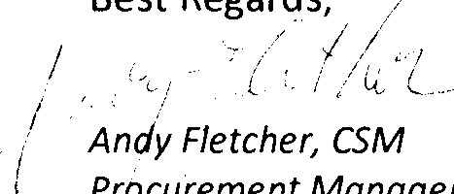
Best
Regards,
Procurement
Manager
&
Project Specialist for Science and Research
Business Services
University of Arkansas — Fayetteville

