Attachment A - Current Food and Concession Locations Page 1
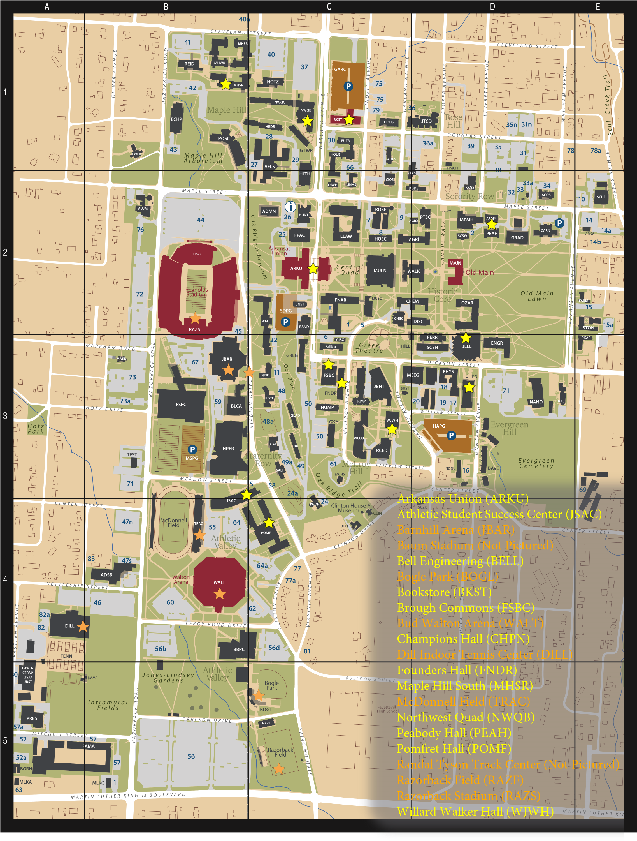
Attachment A - Current Food and Concession Locations Page 2 Campus Map

LOCATION | CODE | NAME
C2 | ADMN | A dministration Building - Honors College
B4 | ADSB | Administrative Services Building (including parking office)
C1 | AFLS | Agricultural, Food, and Life Sciences Building - Dale Bumpers College of Agricultural, Food and Life Sciences
D2 | AGRX | Agriculture Annex
D2 | AGRI | Agriculture Building
C1 | ADPS | Alpha Delta Pi
B2 | AGRF | Alpha Gamma Rho
D2 | AOPS | Alpha Omicron Pi
B3 | MARK | Alpha Phi Alpha
B2 | ALUM | Alumni House (Janelle Y. Hembree Alumni House)
C2 | ARKU | Arkansas Union
D2 | ARMY | Army ROTC Building
C2 | BAND | Band Hall (Lewis E. Epley, Jr. Band Building)
B3 | JBAR | B arnhill Arena Gymnastics Center (John Barnhill Arena Gymnastic Center)
D3 | BELL | Bell Engineering Center - College of Engineering
C2 | MUSC | B illingsley Music Building (George and Boyce Billingsley Music Building)
C5 | BOGL | Bogle Park
C1 | BKST | University Bookstore
B3 | BLCA | Lewis Center for Women’s Athletics (Bev Lewis Center for Women’s Athletics)
D3 | BGHL | Botany Greenhouse
C3 | FSBC | Brough Commons
B2 | FBAC | Broyles Athletic Center (Frank Broyles Athletic Center)
C3 | BUCH | Buchanan-Droke Hall
B4 | WALT | Bud Walton Arena
C2 | WAHR | Bud Walton Hall
C3 | WCOB | Business Building - Sam M. Walton College of Business
E4 | KUAF | Carver Center for Public Radio
D3 | HEAT | Central Utility Plant
A5 | CERM | Ceramics Studio
C2 | CHBC | Chemistry and Biochemistry Research Building
D2 | CHEM | Chemistry Building
C2 | CIOS | Chi Omega
C3 | COGT | Chi Omega Greek Theatre
D3 | CHIL | Chiller Plant
C4 | CLIN | Clinton House Museum
C2 | DAVH | Davis Hall
D2 | DDDS | Delta Delta Delta
A4 | DILL | Dills Indoor Tennis Center
D2 | DISC | Discovery Hall (formerly known as Science Building)
D3 | DUNR | Duncan Avenue Residence - Apartments
A5 | EAWH | Eastern Avenue Warehouse - Surplus Property
D2 | CARN | Ella Carnall Hall
D3 | ENGR | John A. White, Jr. Engineering Hall
C2 | BAND | Epley Band Hall (Lewis E. Epley, Jr. Band Building)
B1 | ECHP | Epley Center for Health Professions
B5 | FAMA | Facilities Management
A5 | PPRC | Facilities Management Recycling
E2 | FARM | Farm House
D3 | FERR | Ferritor Hall (Daniel E. Ferritor Hall)
C2 | FLDH | Field House
C2 | FNAR | Fine Arts Center
C3 | FNDR | Founders Hall
B1 | FWLR | Fowler House (Wallace and Jama Fowler House)
C1 | FUTR | Futrall Hall
C1 | GACR | Garland Avenue Center
C1 | GACS | Garland Avenue Center Shops
C1 | GAPG | Garland Avenue Parking Garage
C3 | GIBX | Gibson Annex
C3 | GIBS | Gibson Hall
C3 | GLAD | Gladson-Ripley Hall
F4 | GLBL | Global Campus
A5 | CTMS | Global Campus Media Services Garage
D2 | GRAD | G raduate Education Building - College of Education and Health Professions
C3 | COGT | Greek Theatre (Chi Omega Greek Theatre)
C3 | GREG | Gregson Hall
B4 | JSAC | Jones Student-Athlete Center
C1 | HRDR | Harding Hall (Arthur M. Harding Hall - Northwest Quad D)
D3 | HAPG | Harmon Avenue Garage
C2 | HLTH | Health Center (Pat Walker Health Center)
B3 | HPER | Health, Physical Education, and Recreation Building
B2 | ALUM | Hembree Alumni House (Janelle Y. Hembree Alumni House)
C3 | HILL | Hillside Auditorium
C1 | HOLC | Holcombe Hall
C2 | HOEC | Home Economics Building
D1 | HMGH | Home Management House
C1 | HOUS | University Housing Office (960 W. Douglas St.)
C2 | HOEC | Human Environmental Sciences Building
C3 | HUMP | Humphreys Hall

C3 JBHT H unt Center for Academic Excellence (J.B. Hunt Transport Service, Inc. Center for Academic Excellence)
D1 INDC Infant Development Center
D2 CARN Inn at Carnall Hall B5 IMMP Intramural Multipurpose Building
D1 JTCD Jean Tyson Child Development Center E2 KDLS Kappa Delta
D2 KKGS Kappa Kappa Gamma
D3 KASF Kappa Sigma
C3 KIMP Kimpel Hall
E4 KUAF KUAF
C3 LCAF Lambda Chi Alpha
C2 WATR Leflar Law Center - School of Law
C2 MULN Library
A5 LISA Library Storage Annex
B1 MHER Maple Hill East
B1 MHSR Maple Hill South
B1 MHWR Maple Hill West
B3 MARK Markham House
B4 TRPA McDonnell Field (John McDonnell Field House)
C3 MCHS McIlroy House
D2 STAB McNalley House B3 MSPG Meadow Street Parking Garage
D3 MEEG Mechanical Engineering Building
D2 MEMH Memorial Hall
C2 MULN Mullins Library
C3 GIBX Multimedia Resource Center
C2 MUSC Music Building (George and Boyce Billingsley Music Building)
D3 NANO Nanoscale Material Science and Engineering Building
C1 NWQB Northwest Quad B
C1 NWQC Northwest Quad C B5 CRED Old Credit Union
D2 MAIN Old Main - J. William Fulbright College of Arts and Sciences
D2 OZAR Ozark Hall - Graduate School D2 PEAH Peabody Hall C3 PDTF Phi Delta Theta
C4 PGDF Phi Gamma Delta
D3 PHYS Physics Building
E2 PBPS Pi Beta Phi
E3 PKAF Pi Kappa Alpha
D2 PTSC Plant Sciences Building
C4 POMF Pomfret Hall
C4 POMF Pomfret Honors Quarters
A5 PRES Printing Services / University of Arkansas Press Warehouse
C5 RAZF Razorback Field (Soccer)
A4 BUSB Razorback Transit Maintenance Facility
B1 REID Reid Hall
C3 RCED Reynolds Center for Enterprise Development (Donald W. Reynolds Center for Enterprise Development)
B2 RAZS Reynolds Razorback Stadium (Donald W. Reynolds Razorback Stadium)
C2 ROSE Rosen Alternative Pest Control Center
D2 SCSW School of Social Work
D3 SCEN Science Engineering Building
C3 SAEF Sigma Alpha Epsilon E2 SCHF Sigma Chi
C3 SINF Sigma Nu
C2 HUNT Silas Hunt Hall - Admissions and Registrar
C5 RAZF Soccer
C5 BOGL Softball
B3 SCAC Southeastern Conference Academic Consortium
C2 SDPG Stadium Drive Garage
E2 STON Stone House North (Edward Durrell Stone House)
E2 STOS Stone House South (Edward Durrell Stone House)
D2 STAB Study Abroad and International Exchange
D4 SUZM Suzuki Music School
B3 TEST Testing Center
B3 TSTA Testing Annex
B1 POSC Tyson Building (John Tyson Poultry Science Center)
C4 UTCH UAteach building
C2 ARKU Union (Arkansas Union)
C2 UNST Union Station (Union Station Transit Facility)
C2 UNHS University House
C3 MCHS University Press
D2 WALK Vol Walker Hall
C2 HLTH Walker Health Center (Pat Walker Health Center)
B3 IDPA Walker Pavilion
B4 WALT Walton Arena (Bud Wlton Arena)
E3 WHSE Warehouses
C2 WATR Waterman Hall
E2 WAAX West Avenue Annex
C1 GTWR Willard B. Gatewood, Jr. (Northwest Quad A)
C3 WJWH Willard Walker Hall (Willard J. Walker Hall)
C3 YOCM Yocum Hall C2 ZTAS Zeta Tau Alpha
June 25, 2015

