INVITATION FOR BID (SALE)
UNIVERSITY OF ARKANSAS

SUBMIT BID TO: |  | Office of Business Affairs | Bid Number: | S051118
 |  | 321 Administration Building | Bid Description: | TIMBER SALE
 |  | Fayetteville, AR 72701 | Bid Opening Date: | 06/06/18 | Time: | 2:30 P.M.
 |  | (479) 575-2551 | Inspection Date(s): | See Below
 |  | Attn: Andy Fletcher
THIS OFFICIAL BIDSHEET MUST BE SIGNED AND RECEIVED IN A SEALED ENVELOPE WITH BID NUMBER AND BID OPENING DATE CLEARLY NOTED ON OUTSIDE OF ENVELOPE.

Bids may not be faxed directly to the University in response to this Invitation to Bid.
Bid will be accepted either signed in ink or electronic or facsimile signature.

NAME: |  |  |  |  | TITLE:
ADDRESS: |  |  |  |  | PHONE: _____________FAX:
 |  |  |  |  | DATE:
NAME (TYPE OR PRINT): |  |  |  |  | FEDERAL EMPLOYER I.D. #:
SIGNATURE: |  |  |  |  | OR SOCIAL SECURITY #:

ITEMS LISTED ON THE ATTACHED SHEETS WILL BE SOLD TO THE HIGHEST BIDDER
SUBJECT TO ALL TERMS AND CONDITIONS LISTED HEREIN.
STANDARD TERMS AND CONDITIONS

1. | GENERAL: Any special terms and conditions included in the Invitation for Bid override these standard terms and conditions. The standard terms and conditions and any special terms and conditions become part of any contract entered into if any or all parts of the bid are accepted by the University of Arkansas.
2. | ACCEPTANCE AND REJECTION: The University reserves the right to accept or reject all or any part of a bid or any and all bids, to waive minor technicalities, and to award the bid to best serve the interest of the University.
3. | PRICES: Bid unit price. In case of errors in extension, unit prices will govern. Prices are firm and not subject to escalation unless otherwise specified in the Invitation for Bid. Unless otherwise specified, the bid must be firm for acceptance for thirty (30) days from the bid opening date.
4. | AMENDMENTS: The bid cannot be altered or amended after the bid opening date except as permitted by regulation.
5. | AWARD: Award will be on either a per item or an all or none basis, whichever is more advantageous to the University.
6. | PATENTS OR COPYRIGHTS: The contractor agrees to indemnify and hold the University harmless from all claims, damages and costs, including attorneys’ fees, arising from infringement of patents or copyrights.
7. | ASSIGNMENT: Any contract entered into pursuant to this Invitation for Bid is not assignable nor the duties thereunder delegable by either party without the written consent of the other party of the contract.
8. | INSPECTION: The bidder is invited, urged and cautioned to inspect property to be sold prior to submitting a bid. Property will be available for inspection at the place and times specified in the Invitation For Bid. In no case will failure to inspect constitute grounds for withdrawal of a bid after opening. Deficiencies, when known, have been indicated in the item description. However, absence of any indicated deficiency does not mean the item may not have deficiencies. Any oral statement or representation by any representative of the University is unauthorized and shall confer no right upon the Bidder or Purchaser. Withdrawal of a bid must be made before the bid opening time, in writing and presented to the above Buyer.
9. | CONDITION OF PROPERTY: Unless otherwise specifically provided in the Invitation For Bid, all property is offered for sale “as is, where is.” The description is based on the best available information. However, the University makes no warranty, expressed or implied, as to quality, kind, character, quantity, weight, size or description of any of the property or its fitness for any use or function.
10. | WEIGHING: Where weighing is necessary to determine the exact purchase price hereunder, the purchaser shall arrange for and pay all expenses of weighing material.
11. | PAYMENT: The purchaser agrees, upon notification, to pay for the item(s) awarded to him/her in accordance with the prices quoted in his/her bid. Payment is to be made in the form of cashier’s check, certified check, or bank draft.
12. | TITLE: Unless otherwise specified in the Invitation For Bid, title to the items or property sold hereunder shall vest in the purchaser when full payment is made.
13. | REMOVAL OF PROPERTY: Unless otherwise specified in the Invitation For Bid, the purchaser shall be entitled to obtain the property upon vesting of title or the receipt of payment for the property to him/her. The purchaser shall remove the property at his/her expense. In no way will the University of Arkansas suffer any expense, penalty, personal or property liability in the removal of said equipment.
14. | STATE SALES AND/OR USE TAX: Purchaser of personal property from the University of Arkansas may be subject to the payment of a state sales and/or use tax. The University of Arkansas is not responsible for collection of state tax.
15. | SPECIAL NOTICE: Failure to respond to three (3) consecutive Invitations For Bid or notices of bid shall be considered sufficient cause to remove your name from the bidder’s list.
16. | CONTRACT WITH THE UNIVERSITY: A signed Invitation For Bid constitutes a contract with the University of Arkansas to pay the amount indicated for the equipment/items offered for sale. Failure to comply could result in action being taken by the Attorney General’s Office and/or be cause for rejection of all future bids. Unsigned bids will not be read or considered. By signing the contract the bidder warrants that they are not under eighteen (18) years of age. Employees of the Department of Finance and Administration, State of Arkansas, may not bid.
17. | DISPUTES: Except as otherwise provided in this contract, any dispute concerning a question of fact arising under this contract which is not disposed of by agreement, shall be decided by the Business Manager. Tie bids will be determined by a flip of a coin by the staff of the University’ Purchasing Department.
18. | OTHER REMEDIES: In addition to the remedies outlined herein, the contractor and the University have the right to pursue any other remedy permitted by law or in equity.

Time of Performance

Time is of the essence in the rendering of services hereunder. Proposer agrees to perform all obligations and rendering of services set forth in this RFP.

Contracting Authority

Contractor shall perform all services as an independent Contractor and shall discharge all of its liabilities as such. No acts performed or representation made, whether written or oral, by Contractor with respect to Third Parties shall be binding to the University.

Default
In the event that the Proposer fails to carry out or comply with any of the Terms and Conditions of the contract with the University, the University may notify the Proposer of such failure or default in writing and demand that the failure or default be remedied within ten (10) working days; and in the event the Proposer fails to remedy such failure or default within the ten (10) working day period, the University shall have the right to cancel the contract upon thirty (30) days written notice.

The cancellation of the contract, under any circumstances whatsoever, shall not effect or relieve Proposer from any obligation or
liability that may have been incurred or will be incurred pursuant to the contract and such cancellation by the University shall not limit
any other right or remedy available to the University by law or in equity.

Qualifications of Bidder

The University may make such investigations as it deems necessary to determine the ability of the bidder to meet all order and delivery requirements as stated herein and the bidder shall furnish to the University all such information and data for this purpose that the University may request. The University reserves the right to reject any bid if the evidence submitted by, or investigations of, such bidder fails to satisfy the University that such bidder is properly qualified to carry out the obligations of the Agreement.

Indemnification

Contractor agrees to indemnify and hold harmless the University and its officers and employees from any claim, damage, liability, injury, expense, or loss, including defense cost and attorney’s fees arising out of Contractor’s performance under this Agreement or as a consequence of the existence of this Agreement.

Permits and Licenses

Contractor shall, at its sole expense, procure and keep in effect all necessary permits and licenses required for its performance under this Agreement, and shall post or display in a prominent place such permits and/or notices as are required by law.

Termination

In the event that the Contractor shall fail to maintain or keep in force any of the terms and conditions of the Contract, the University may notify the vendor in writing of such failure and demand that the same be remedied within Ten (10) days. Should the Contractor fail to remedy the same within said period, the University shall then have the right to terminate the Contract by giving the Contractor thirty (30) days written notice.

Right to Audit

At any time during the term of the agreement and for a period of four (4) years thereafter the University duly authorized audit representative, at its expense and at the reasonable times, reserves the right to incrementally audit Proposer’s records and manufacturer’s pricing relevant to all pricing provided under this agreement. In the event such an audit by the University reveals any error/overpayments, the Proposer shall refund the University the full amount of such overpayments within thirty (30) days of such audit findings, or the University at its option, reserves the right to deduct such amounts plus interest owing the University from any payments due Seller.

Acceptance of Products and Services

All products furnished and all services performed under this agreement shall b
to the satisfaction of the University and in accordance with the specifications, terms, and conditions of the agreement. The University reserves the right to inspect the products furnished or the services performed, and to determine the quality, acceptability, and fitness of such products or services.

Severability

If one or more provisions of the resultant agreement, or the application of any provision to any party or circumstance is held invalid, unenforceable, or illegal in any respect, the remainder of the agreement and the application of the provision to other parties or circumstances shall remain valid and in full force and effect.

Non-Waiver of Defaults

Any failure of the University at any time, to enforce or require the strict keeping and performance of any of the terms and conditions of this agreement shall not constitute a waiver of such terms, conditions, or rights, and shall not affect or impair same, or the right of the University at any time to avail itself of same.

Governing Law

This agreement shall be construed and governed by the laws of the State of Arkansas.

SEE NEXT PAGE

INVITATION TO BID ON BLACK WALNUT TIMBER

University of Arkansas – Division of Agriculture

Savoy Research Unit – Washington County

May 2018

SUMMARY:

Seller: University of Arkansas – Division of Agriculture

Timber for Sale: Black Walnut standing sawtimber/veneer

Location: Savoy Research Unit, Washington County, Arkansas, west of Fayetteville

Sale/payment type: Lump sum

Bid deadline: 2:30 p.m. Wednesday, June 6, 2018
NOTE: Site visits during the bid period will be by appointment only

Acres in sale area: approximately 16 acres – creek bottom (2 separate areas)

Number of black walnut trees: 62

Tree diameter (DBH) range: 17-38 inches

BID:
Lump sum for all designated black walnut trees: $ _____________________________

Bidder name: ___________________________________________________ Phone # _________________________

The University of Arkansas (Seller) is offering for sale to the highest bidder (Buyer), black walnut standing timber, located on the Savoy Research Unit, west of Fayetteville, Arkansas on Washington County Road #845. Bids (lump sum) should be submitted for all the marked and designated black walnut timber within the sale area. Payment will be made on a lump sum basis. Submit bids by 2:30 pm., Wednesday, June 6, 2018, to:

University of Arkansas
Office of Business Affairs
321 Administration Building
Fayetteville, Arkansas 72701
479-575-2551

Attn: Andy Fletcher

Following is a prospectus of information and conditions for bid and sale. Further information may be obtained from: Mr. Chris Stuhlinger, University Forester, University of Arkansas, School of Forest Resources, P.O. Box 3468, Monticello, AR 71656, (870) 460-1749 or Mr. Vaughn Skinner, Resident Director, AAREC, University of Arkansas, 1366 Altheimer Dr., Fayetteville, AR 72704, (479) 841-3462, prior to submission of bid.

- LOCATION: The timber is located on the University of Arkansas Savoy Research Unit in Washington County. The Savoy Research Unit entrance is located at the UA Animal Science Unit (Beef Farm) gate on County Road 845 about 1.3 miles west of County Road 31 in Washington County. Take Hwy. 16 (Wedington Dr.) about 5 miles west of I-540 exit #64 and turn north on CR 31, or take Hwy 412 (de Tonti Blvd.) about 5 miles west of I-540 exit #72 and turn south on CR 31 (Harmon Rd.). The Farm Manager’s (Pete Hornsby) office is located inside the entrance gate (18001 West UA Beef Farm Rd. 72704). The harvest block is located in Section 19, T 17 N, R 31 W.

  - The timber is contained along two creek bottoms (total area about 16 acres), as shown on the attached maps. Access to the harvest area will be at two locations as shown on the attached map.

  - Bids (lump sum) must be submitted for the entire sale area.

- BIDDING PROCEDURES: A designated time has been established for potential bidders to visit and evaluate the black walnut trees in this sale area. Visits to the site of the sale will be by appointment only. To set up an appointment, contact Chris Stuhlinger, University Forester, at 870-723-5181 (mobile), 870-460-1749 (office), or by e-mail Stuhlinger@uamont.edu. Two 2-day periods have been established for appointments: May 21 (1-4 pm), May 22 (8-4 pm), May 23 (8-12 pm), and May 30-31 (between 8:00 a.m. and 4 p.m. each day). Appointments must be made at least 3 business days in advance. If you cannot make your appointment, please advise as soon as possible. Appointments will be rescheduled in case of bad weather.

Bidders are strongly encouraged to maximize the utilization of each tree, which could include multiple products (veneer, sawtimber, specialty products, hobby wood, etc.). Lump sum bids should be based on the total value and utilization of all the designated black walnut trees.

- BID FORMAT and DEPOSIT: Bids must be submitted in the following format:
Lump sum for all designated black walnut trees: $ ________________________

Bidder name: _______________________________________________________

Bidder Phone number: ____________________________________
NOTE: A deposit of ten percent (10%) must be submitted with each bid and will be applied to the purchase price of the successful bidder. Bid deposits must be by cashier’s check payable to “The University of Arkansas”. The right to reject any and all bids is reserved. Deposits on bids not accepted will be refunded as soon as possible after opening of bids.

Submit bids (with Deposit) by 2:00 pm., Wednesday, June 6, 2018, to:

University of Arkansas
Office of Business Affairs
321 Administration Building
Fayetteville, Arkansas 72701
501-575-2551

Attn: Andy Fletcher

- PAYMENT: Bid price (lump sum) will cover all black walnut timber marked for sale within the designated sale area. The total payment of the bid price will be required within fourteen (14) days of the Buyer’s notification of being awarded the purchase contract, and before any timber is cut. Payment must be by cashier’s check payable to “The University of Arkansas”. Payment should be mailed or delivered to Mr. Vaughn Skinner, Resident Director, AAREC, University of Arkansas, 1366 Altheimer Dr., Fayetteville, AR 72704, (479) 841-3462. The Buyer is responsible for any severance taxes.

- ESTIMATE OF VOLUME: A summary of the estimated timber volume is NOT provided. However, a listing of each black walnut tree’s estimated diameter (DBH) and butt log lengths is provided. Each bidder is expected to make their own cruise (by appointment only as described above) and make their bid based on their own volume estimate. There is no representation or guarantee by the Seller as to the volume of timber that has been designated for removal. The diameters and log lengths were estimated by measuring the diameter of each marked tree at breast height (DBH), and the length of each butt log to the first major defect. Information about each tree is listed (see attached) in two ways: 1) by tree number (#1-62, roughly east to northwest along the creeks, and 2) by tree diameter (DBH) from smallest to largest diameter.

- CUTTING PROCEDURES: All black walnut timber to be cut and sold has been marked with a yellow number (1-62) at head height and a yellow paint mark at stump height. All designated black walnut trees are located within 200 feet of a woods road, and the vast majority are much closer (within 50-100 feet). Please fell only the black walnut trees that you will utilize.
Access roads and loading/decking sites must be agreed to by the Seller and Buyer.

Care must be taken to prevent damage to the remaining trees, especially black walnut trees, in and surrounding the entire harvest area. The Buyer will be assessed a penalty of double average stumpage value, determined by the Seller, for excessive damage to any remaining non-walnut trees (greater than 13 inches DBH) during felling or transporting activities. The Buyer will be assessed a penalty of triple average stumpage value, determined by the Seller, for excessive damage to any remaining black walnut trees (greater than 10 inches DBH) during felling or transporting activities. The same penalties will apply to any unmarked or undesignated trees that are cut. Stumps of trees cut shall be no higher than 12 inches above average ground line, except for those trees with wire, nails, visible defect, or excessive flare that necessitates cutting a stump higher than 12 inches.

- FENCES, ROADS, GATES, ETC.: All current roads must be kept usable, and free of debris. The Buyer agrees to repair, at his own expense, damage caused by his operation to fences, roads, gates, bridges and culverts. The Buyer agrees to close out, at his own expense, any temporary roads or trails built for the extraction of the timber, including the cost of returning any trail to grade, water bars, and water turnouts. The Buyer may deck extracted timber outside the harvest block only in areas designated by Station personnel for that purpose. All logging debris must be returned to the cut area. Any old fences (except property boundary fences) found within the perimeter of the parcels to be harvested may be destroyed. Access to the woods road on the east end of the harvest area through the field will be designated by Station personnel.

- ACCESS and SUPERVISION: The Buyer and his agents shall have normal access on and across the property for the purpose of conducting harvesting operations during the time frame of this agreement. The Buyer must designate an on-site supervisor. The Seller reserves the right to check cutting operations at any time to determine whether or not the provisions of this agreement are being carried out. The Buyer or their agents are not employees of the Seller, but are independent contractors.

- WET PERIODS: If the condition of the ground during wet periods results in rutting greater than 6 inches in depth in the woods, or road damage is determined objectionable by the Resident Director and/or the System Forester, the Buyer may be asked to suspend cutting and hauling activities. Down time due to wet ground conditions and requested by the Resident Director and University Forester is not chargeable to, and will be added to the end of the term of the contract. Down time not requested by the Resident Director and University Forester is chargeable to the term of the contract and will not be added to the ending dates.

- BEST MANAGEMENT PRACTICES: The Buyer will in all respects observe and follow all Arkansas Best Management Practice guidelines as applicable, and as explained in the Arkansas Forestry Commission’s “Arkansas Forestry Best Management Practices for Water Quality Protection” booklet (available on-line at http://www.agriculture.arkansas.gov/Websites/aad/files/Content/5944986/BMPs.pdf). These include, but are not limited to:

1. Observe, and restrict activities in, streamside management zones (SMZs).
2. Streams should be crossed at right angles, using bridges, culverts, low water fords (stone), or
other suitable materials.
3. Use wing ditches, broad-based dips, rolling dips, crowning, and diversion ditches to maintain
good road drainage.
4. Harvest site landings should be located away from streams and SMZs on fairly level ground.
5. Skid trails should follow contours as much as possible.
6. Temporary stream/slough crossings must be restored to original condition prior to harvest closeout.
7. See also Section XIX – proper seeding, installation of water bars, etc.

Proper BMPs must be in place prior to any temporary breaks (down time) in harvest activities.

- FIRE CONTROL MEASURES: The Buyer will exercise due care to prevent fires and will be responsible for control of all fires occurring in the sale area.

- CONTRACT PERIOD: The contract period will be for approximately twelve (12) months, starting from the date the contract is awarded, but ending no later than June 30, 2019. Any merchantable tree, or any cut forest product, within the prescribed area not removed at the termination of this agreement becomes the property of the Seller.

- INSURANCE COVERAGE: The Buyer shall maintain general liability and auto liability insurance, and Worker’s
Compensation insurance as required by the State of Arkansas. Copies of certificates showing proof

1. Workers Compensation: (a) as required by the State of Arkansas. (b) Employer’s Liability - $100,000.00 each.

2. Comprehensive General Liability: (including premises operations; independent contractor’s protective; products and completed operations; broad form property damage).

3. (a) Bodily Injury: $1,000,000.00 each occurrence, $1,000,000.00 aggregate.
Products and completed operations.
(b) Property Damage: $1,000,000.00 each occurrence, $1,000,000.00 aggregate.

4. Business Automobile Liability Insurance – The Buyer shall be required to maintain automobile liability insurance and shall file certificates with the University.
Insurance policies shall be written by a company or companies authorized to do business in the State of Arkansas. The limits of liability of such insurance shall be written for not less than the following:
- Comprehensive Business Automotive Liability (including owned, non-owned and hired vehicles)
with a combined single limit of $500,000.00 per occurrence.
- Medical Payments (each person) $5,000.00
- Uninsured and underinsured Motorist Coverage with a combined single limit for bodily injury and
property damage for not less than $500,000.00 per occurrence.

5. Subcontractors: The Buyer is responsible for any subcontractors hired by the Buyer to assist with any aspects of the harvest operation. This includes, but is not limited to, felling, skidding, loading, and clean-up on the harvest site, and transporting timber from the harvest site to the mill. This requires that the Buyer maintains adequate insurance coverage, as described in Section X., to cover any subcontracted work and workers.
6. The “Board of Trustees of the University of Arkansas acting for and on behalf of the University
of Arkansas, Fayetteville” must be named as an Additional Insured.

XIV .PERFORMANCE BOND: The Buyer will secure a performance bond in the amount of $1000 or deposit $1000
with the Seller to be held until the completion of this contract against damages caused by the operation of
harvesting timber.

- COUNTY, STATE and FEDERAL LAWS: The Buyer agrees to comply with all applicable County, State and
Federal laws during the completion of this contract.

- TITLE: Title to and responsibility for the trees shall pass to the Buyer as they are severed from the stump, but th
Seller retains and the buyer grants a vendor’s lien on all forest products cut or removed from the property until paid
in full.

XVII The Seller is free from responsibility for any injury, death or property damage caused by the Buyer’s logging
operation during the tenure of this agreement.

XVIII .HARVEST CLOSEOUT: Before harvest completion, the Buyer (harvest operator) must contact and meet with the
Station Director and/or University Forester prior to leaving the harvest site so that a final closeout inspection can be
conducted. Items to be examined include but are not limited to:

1. Smooth roads, skid trails, and log landings as possible (no deep ruts or high debris piles).
2. After harvest completion, restore to pre-harvest condition the access roads and stream crossings, including
rolling dips and broad-based dips.
3. Temporary and inactive roads should have properly constructed water bars in place.
4. All logging debris must be removed from streams/sloughs.
5. Clean out ditches along public roads to original condition.
6. Revegetate landings and skid trails after harvest completion.
7. Clean up and haul litter, such as oil cans, grease containers, etc.
8. Buyer waives all claim to above described trees located on the above described property after final harvest
closeout determined by Station Director and/or System Forester.

Black Walnut Timber Sale 2018 Individual Tree Data
Listed by TREE NUMBER

Tree # | DBH, inches | Butt log length to first defect, ft | Straightness | Defects | Other Comments
1 | 29 | 15-18 | straight
2 | 38 | 8-10 |  | 2 small | depression west side
3 | 26 |  | straight
4 | 21 | 8 | straight | basal
5 | 34 | 10 | crook |  | lean
6 | 21 | 12-14 | straight |  | slight lean
7 | 18 | 9 | straight
8 | 21 | 10 |  |  | lean
9 | 38 | 20 | straight
10 | 18 | 25 | straight
11 | 27 | 12-15 |  | basal & small
12 | 24 | 12 | small crook
13 | 27 | 12-15 | straight
14 | 20 | 15-20 | straight
15 | 20 | 25 | straight |  | slight lean
16 | 21 | 18-20 | straight
17 | 19 | 10-12 | straight
18 | 23 | 8-10 | straight
19 | 20 | 15 | straight
20 | 20 | 20 | straight
21 | 27 | 10-12 | crook
22 | 22 | 12-15 | straight
23 | 23 | 8-10 |  |  | slight lean
24 | 20 | 15-20 | crook
25 | 18 | 25 | small crook
26 | 19 | 10-12 | crook
27 | 22 | 15-20 | straight |  | slight lean
28 | 23 | 15-20 | straight
29 | 19 | 15 | small crook
30 | 26 | 10-12 | straight
31 | 23 | 15-20 | crook
32 | 28 | 20-25 | straight
33 | 22 | 12-15 | straight | small basal
34 | 18 | 25 | straight
35 | 22 | 10-12 | straight
36 | 18 | 15-20 | straight
37 | 25 | 10-12 | straight
38 | 30 | 15-20 | straight | small
39 | 22 | 20 | straight
40 | 26 | 20-25 | straight | small

Tree # | DBH, inches | Butt log length to first defect, ft | Straightness | Defects | Other Comments
41 | 22 | 15-20 | straight |  | slight lean
42 | 23 | 8-10 | crook
43 | 19 | 15-20 | straight
44 | 21 | 25 | crook
45 | 21 | 20-25 | straight
46 | 24 | 10-12 | straight
47 | 27 | 10-12 | straight
48 | 21 | 20-25 | slight crook
49 | 17 | 20 | straight
50 | 20 | 20-25 | straight
51 | 18 | 25 | straight | small
52 | 24 | 15-20 | straight
53 | 22 | 8-10 | straight
54 | 19 | 10 | straight
55 | 23 | 15-18 | straight
56 | 19 | 15-20 | straight
57 | 26 | 20 | straight
58 | 22 | 18-20 | straight
59 | 20 | 25 | slight crook
60 | 21 | 10 | straight
61 | 24 | 15 | straight | decay at 4 ft.
62 | 21 | 10-12 | slight crook | small

Black Walnut Timber Sale 2018 Individual Tree Data

Sorted by TREE DIAMETER (DBH, inches)

Tree # | DBH, inches | Butt log length, feet
49 | 17 | 20
7 | 18 | 9
10 | 18 | 25
25 | 18 | 25
34 | 18 | 25
36 | 18 | 15-20
51 | 18 | 25
17 | 19 | 10-12
26 | 19 | 10-12
29 | 19 | 15
43 | 19 | 15-20
54 | 19 | 10
56 | 19 | 15-20
14 | 20 | 15-20
15 | 20 | 25
19 | 20 | 15
20 | 20 | 20
24 | 20 | 15-20
50 | 20 | 20-25
59 | 20 | 25
4 | 21 | 8
6 | 21 | 12-14
8 | 21 | 10
16 | 21 | 18-20
44 | 21 | 25
45 | 21 | 20-25
48 | 21 | 20-25
60 | 21 | 10
62 | 21 | 10-12
22 | 22 | 12-15
27 | 22 | 15-20
Tree # | DBH, inches | Butt log length, feet
33 | 22 | 12-15
35 | 22 | 10-12
39 | 22 | 20
41 | 22 | 15-20
53 | 22 | 8-10
58 | 22 | 18-20
18 | 23 | 8-10
23 | 23 | 8-10
28 | 23 | 15-20
31 | 23 | 15-20
42 | 23 | 8-10
55 | 23 | 15-18
12 | 24 | 12
46 | 24 | 10-12
52 | 24 | 15-20
61 | 24 | 15
37 | 25 | 10-12
3 | 26
30 | 26 | 10-12
40 | 26 | 20-25
57 | 26 | 20
11 | 27 | 12-15
13 | 27 | 12-15
21 | 27 | 10-12
47 | 27 | 10-12
32 | 28 | 20-25
1 | 29 | 15-18
38 | 30 | 15-20
5 | 34 | 10
2 | 38 | 8-10
9 | 38 | 20

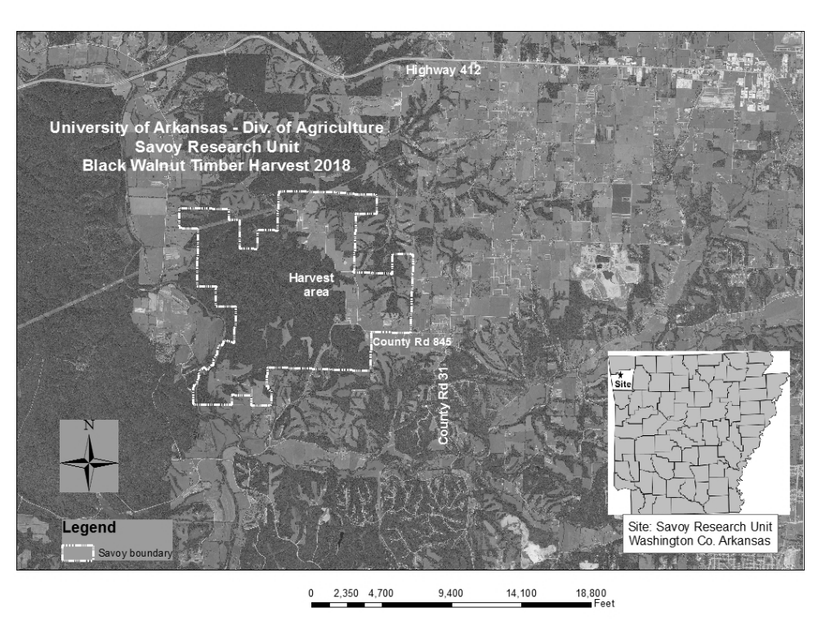

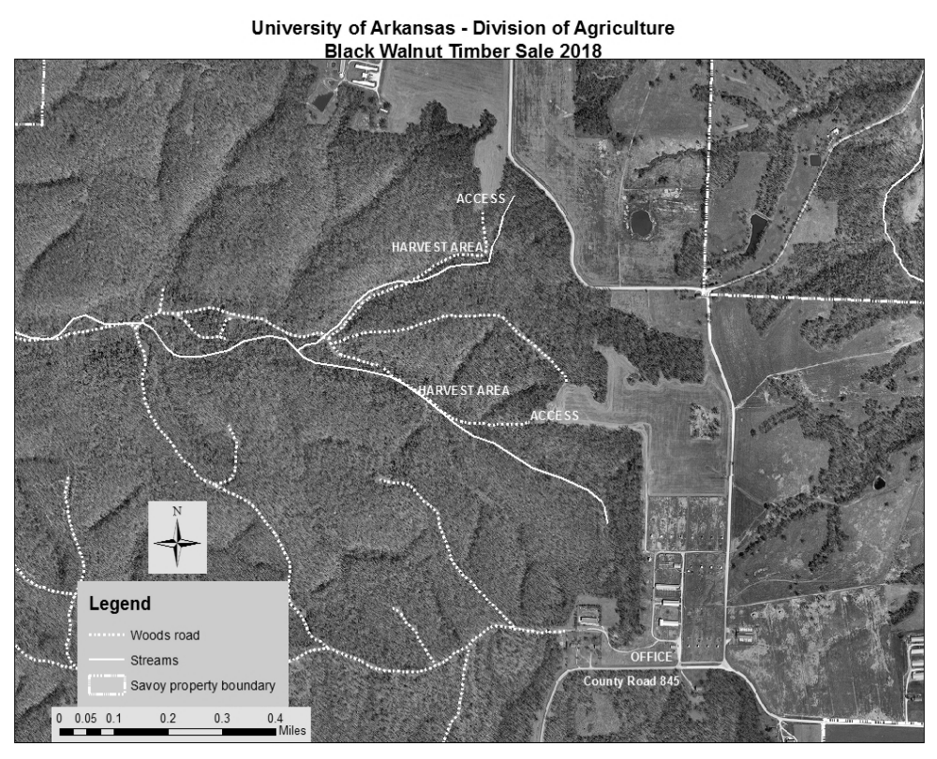

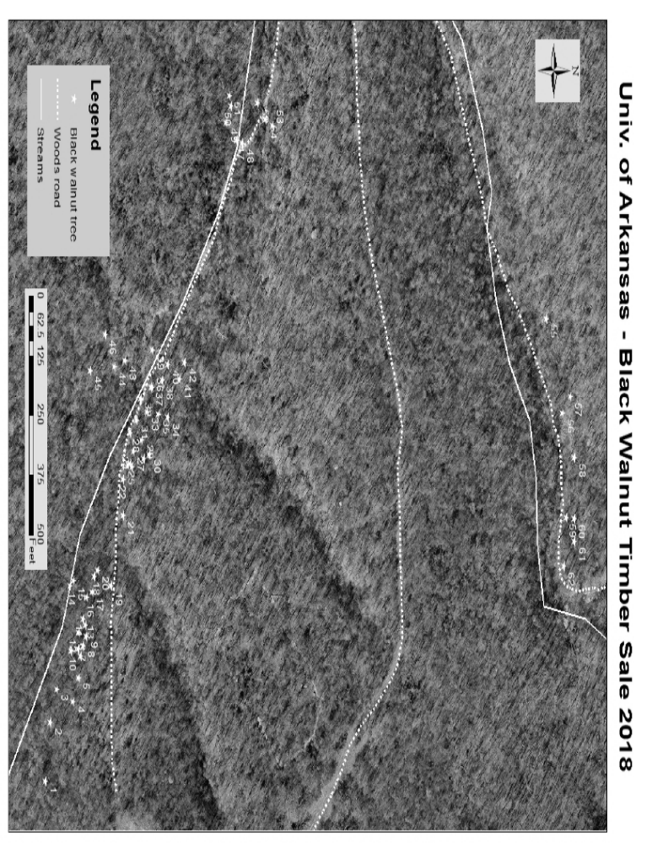

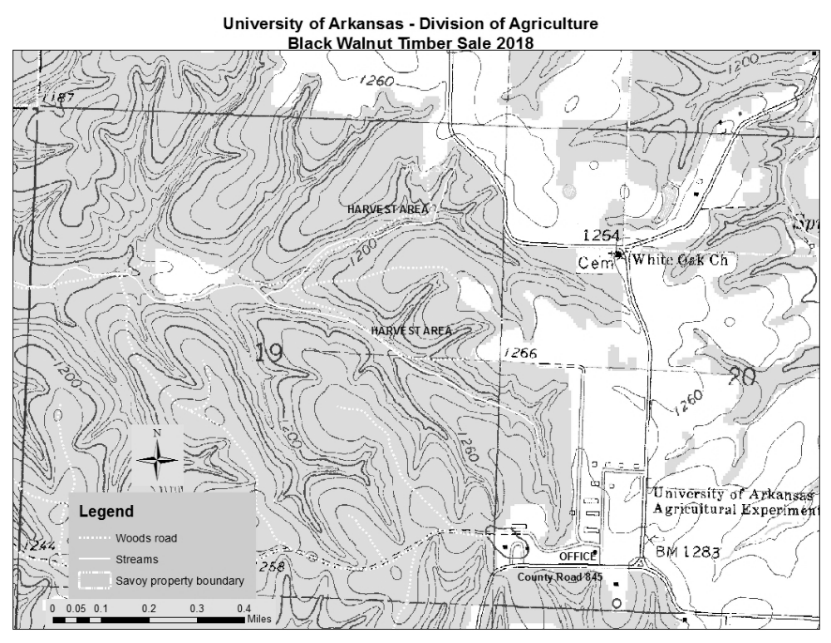

Equal Opportunity Policy Disclaimer

ATTENTION BIDDERS

Act 2157 of 2005 of the Arkansas Regular Legislative Session requires that any business or person bidding, who is responding to a formal bid request, Request for Qualifications or qualifications, or negotiating a contract with the state for professional or consultant services, submit their most current equal opportunity policy (EO Policy).

Although bidders are encouraged to have a viable equal opportunity policy, a written response stating the bidder does not have such an EO Policy will be considered that bidder’s response and will be acceptable in complying with the requirement of Act 2157.

Submitting the EO Policy is a one-time requirement. The University of Arkansas, Fayetteville Procurement Department, will maintain a database of policies or written responses received from all bidders.

Note: This is a mandatory requirement when submitting an offer as described above.

Please complete and return this form with your bid response.

Should you have any questions regarding this requirement, please contact this office by calling (479) 575-2551.

Sincerely,

Linda Fast

Linda Fast, APO, CPPO, CPPB
Manager of Procurement Services
University of Arkansas

To be completed by business or person submitting response: (check appropriate box)

____ EO Policy Attached

____ EO Policy previously submitted to Procurement Department

____ EO Policy is not available from business or person

Company Name
Or Individual: __________________________________________________________

Title: _____________________________________Date: ______________________

Signature: ____________________________________________________________
UNIVERSITY OF ARKANSAS
PROCUREMENT DEPARTMENT
1125 W. Maple ADMIN 321
Fayetteville, AR 72701
Tel: 479-575-2551
Fax: 479-575-4158

Act 157 of 2007 of the Arkansas Regular Legislative Session requires that any contractor, business or individual, having a public contract with a state agency for professional services, technical and general services, or any category of construction, in which the with the total dollar value of the contract is $25,000 or greater must certify, prior to the award of the contract, that they do not employ or contract with any illegal immigrants.

For purposes of this requirement, “Illegal immigrants” means any person not a citizen of the United States who has:

- Entered the United States in violation of the Federal Immigration and Naturalization Act or regulations issued the act;
- Legally entered but without the right to be employed in the United States; or
- Legally entered subject to a time limit but has remained illegally after expiration of the time limit.

This is a mandatory requirement. Failure to certify will result in our inability to issue a Purchase Order or Contract to you or your company.

Bidders shall certify online at http://www.arkansas.gov/dfa/procurement/pro_immigrant.html
Click on: “Procurement” on left-side information bar
Click on: Illegal Immigrant Reporting
Click on: “Vendor” Illegal Immigrant Contracting Disclosure Reporting Screen
Click on: “Vendor Submit Disclosure Form” to complete all fields required for the certification – then indicate below and sign this form to submit with your bid. ***NOTE*** Bid Number field is applicable if known.
REQUIRED: Print Screenshot and include with your proposal and/or contract.

If you have any questions, please call the UA Procurement Department at 479-575-2551.

Thank you.
Linda K. Fast
Linda K. Fast, CPPO, CPPB, APO
Manager of Procurement Services
University of Arkansas

**********************************************************************************************
TO BE COMPLETED BY BUSINESS OR PERSON SUBMITTING BID RESPONSE OR CONTRACT:

Please check the appropriate statement below:

_______ We certified that we are not an illegal immigrant
or do not employ or contract with any illegal immigrants.

Date of certification: ________________________

_______ We cannot so certify at this time, and we understand that
a contract cannot be awarded until we have done so.

Reason for non-certification: ______________________________

Name of Company: ___________________________________________

Signature: ___________________________________________

Name & Title: ___________________________________________
(Printed or typed)
Date: ___________________________________________




