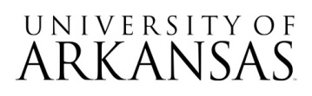

**Request for Proposals (RFP)**

**#10302024**

**Rebranding Campaign for Parking & Transit Operations**

**Notice of Formal Bid Opening Event**

The **virtual only** bid opening event will take place on December 18, 2024, 2:30 PM CST.

[**Join the meeting now**](https://teams.microsoft.com/l/meetup-join/19%3ameeting_OTJjYmJjMWEtYzJjMC00NDRjLWE1YjctYjkwZjBmYTBmZGZk%40thread.v2/0?context=%7b%22Tid%22%3a%2279c742c4-e61c-4fa5-be89-a3cb566a80d1%22%2c%22Oid%22%3a%223f815ba6-9848-4edf-ac78-bf2aa1b6b686%22%7d)

Meeting ID: 219 151 670 520

Passcode: jKY6AD

Attending the bid opening event is not required. No award will be made at the time of bid opening.