

**Request for Proposal (RFP)**

**#09102024**

**Online Proctoring Services**

**Q&A ADDENDUM #1**

1. On Page 22 of the RFP document, the pricing sheet requests a total sum for proctoring services. Is this meant to be the full cost for the entire, initial 4-year term, for the 4-year initial term and the 3 additional years, or detailed otherwise?

Answer: Complete the detailed pricing on Page 22. The University is interested in seeing the per unit price, per student price, subscription price, etc., as the total may vary based on actual exam numbers, number of students, etc.

2. How many students use remote proctoring tools each year (or during the past year)?

Answer:

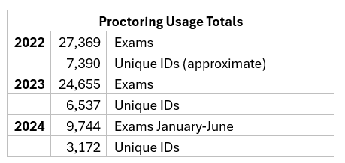

3. Volume chart indicates approx. 22K proctored sessions in the past 3 semesters. Are all of the sessions live/online proctored? If so, how many unique students consumed those sessions? If they are not all live/online proctored sessions, can you provide an approx. % of which ones only used lockdown/monitor?

Answer:

