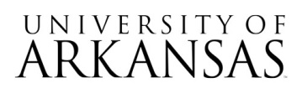

Request for Proposal (RFP)
06092026
SLATE Admissions Platform Consultancy

Notice of Formal Proposal Opening Event

The virtual only proposal opening event will take place on August 05, 2026, at 2:30 PM CDT.
________________________________________________________________________________
Microsoft Teams meeting
Join: https://teams.microsoft.com/meet/254314228324339?p=Oe699z8Q93JdMABXUd
Meeting ID: 254 314 228 324 339
Passcode: GK3hG7NR

Attending the proposal opening event is not required. No award will be made at that time. Only names of respondents and a preliminary determination of proposal responsiveness will be made.

