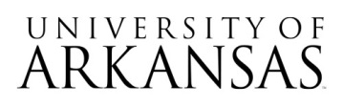

Request for Proposal (RFP)
RFP #06092026
SLATE Admissions Platform Consultancy

ADDENDUM #1
Friday, June 19, 2026

Sections of the RFP Document have been revised to match the information on HOGBID and the rest of the RFP due dates. Those sections are as follows:
With Respect to the Request for Proposal Document:
- Pages 1,6, and 23 have been changed to reflect amended timetable for the RFP.
New dates are as follows:

July 14, 2026, 10:00 AM CDT - Mandatory Pre-Proposal Conference

July 21, 2026, 5:00 PM CDT - Last date/time UA will accept questions

July 22, 2026, Last date UA will issue an addendum

August 5, 2026, Proposal Submission Deadline and Bid Opening Event 2:30 PM CDT
Note: Attendance of RFP opening is not required. No award will be made. Only names of respondents, and a preliminary determination of proposal responsiveness will be made at this time.

August 13, 2026, Respondent Presentations Begin

August 29, 2026, Tentative Notice of Intent to Award

Other elements of the RFP remain the same at this time.

Geoff Hulse
Geoff Hulse,
Procurement Coordinator, UAF Business Services

