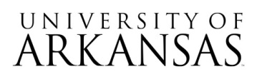

Invitation for Bid (IFB)
07162026
Radiology Workflow Management System
Notice of Formal Bid Opening Event

The virtual only bid opening event will take place on August 06, 2026, 2:30 PM CST.
Microsoft Teams meeting
Join: https://teams.microsoft.com/meet/254830159840285?p=Qd8wau9NpS9lg5v68n
Meeting ID: 254 830 159 840 285
Passcode: vR6K7pf7

Attending the bid opening event is not required. No award will be made at the time of bid opening.

