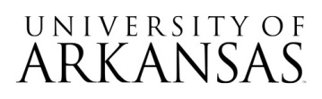

**Invitation for Bid (IFB)**

**#04112025**

**ARE-ON Arkansas Northeastern College Connection**

**Notice of Formal Bid Opening Event**

The **virtual only** bid opening event will take place on May 1, 2025, 2:30 PM CST.

[**Join the meeting now**](https://teams.microsoft.com/l/meetup-join/19%3ameeting_ZTg5NDc1NzUtMTAzMS00YTAxLTllMzktMmNjMzA1ODQxNTY0%40thread.v2/0?context=%7b%22Tid%22%3a%2279c742c4-e61c-4fa5-be89-a3cb566a80d1%22%2c%22Oid%22%3a%223f815ba6-9848-4edf-ac78-bf2aa1b6b686%22%7d)

Meeting ID: 234 097 930 976 3

Passcode: xU7ro3nT

Attending the bid opening event is not required. No award will be made at the time of bid opening.