VENDORS WHO DO NOT WISH TO RESPOND TO A BID ARE NOT REQUIRED TO DO SO.
HOWEVER, VENDORS NOT RESPONDING AND/OR SUBMITTING A “NO BID” RESPONSE TO THREE CONSECUTIVE BID INVITATIONS FOR THE REQUESTED COMMODITY MAY BE REMOVED FROM THE UNIVERSITY’S BIDDERS LIST.

Please Print or Type
Company Name: |  |  | Phone:
Address:
 |  |  | Fax:
City: |  |  | EMail:
State: |  |  | Web Site:
Zip Code:

SIGNATURE REQUIRED FOR RESPONSE

THIS OFFICIAL BID SHEET MUST BE SIGNED AND RECEIVED IN A SEALED ENVELOPE WITH VENDOR NAME, BID NUMBER, AND BID OPENING DATE CLEARLY NOTED ON OUTSIDE OF ENVELOPE IN ORDER FOR BID TO BE ACCEPTED. BID WILL BE ACCEPTED EITHER SIGNED IN INK OR WITH ELECTRONIC OR FACSIMILE SIGNATURE.

BIDS MAY NOT BE FAXED DIRECTLY TO UNIVERSITY IN RESPONSE TO THIS REQUEST FOR PROPOSAL.

NOTE: The above listed date and time is the LATEST the bid will be accepted. ANY bids received after that time will NOT be considered.

NOTE: Pricing awarded on a resulting contract from this bid shall be available to all University of Arkansas departments. Terms stated in the bid response, including pricing and delivery, are available for use outside of the Northwest Arkansas region, but may result in higher shipping costs.

NOTE: All Arkansas state agencies and institutions of higher education may utilize or "Piggy Back"
onto this contract if it is acceptable to the supplier and in the best interest of the institution and the
taxpayers of the state of Arkansas.

By signing below, bidder agrees to furnish the items and/or services listed herein at the prices and/or under the conditions indicated in the official Bid Document.

Name (Type or Print): ________________________________ Title: _______________________________

Signature: ________________________________ Date:_______________________________

STANDARD TERMS AND CONDITIONS

1. | PREPARATION OF BIDS
 | 1.1 | Failure to examine any drawings, specifications, and instructions will be at bidder’s risk.
 | 1.2 | All prices and notations must be printed in ink or typewritten. No erasures permitted. Errors may be crossed out and corrections printed in ink or typewritten adjacent, and must be initialed in ink by person signing bid.
 | 1.3 | Brand Name References: Unless specified “No Substitute” any catalog brand name or manufacturer’s reference used in the bid invitation is descriptive only, not restrictive, and used to indicate the type and quality desired. If bidding on other  than referenced specifications, the bid must show the manufacturer, brand or trade name, and other descriptions, and  should include the manufacturer’s illustrations and complete descriptions of the product offered. The University reserves the right to determine whether a substitute offered is equivalent to and meets the standards of the item specified, and the University may require the bidder to supply additional descriptive material, samples, or demonstrators. The bidder guarantees that the product offered will meet or exceed the referenced product and/or specifications identified in this bid invitation. If the bidder takes no exception to the specifications, bidder will be required to furnish the product exactly as specified in the invitation.
 | 1.4 | Samples: Samples or demonstrators, when requested, must be furnished free of expense to the University. Samples not destroyed during reasonable examination will become property of the University unless bidder states otherwise. All  demonstrators will be returned after reasonable examination. Each sample should be marked with the bidder’s name  and address, bid number and item number.
 | 1.5 | Time of Performance: The number of calendar days in which delivery will be made after receipt of order shall be stated in the bid.
2. | SUBMISSION OF BIDS
 | 2.1 | Bids, modifications or corrections thereof received after the closing time specified will not be considered.
3. | ACCEPTANCE OF BIDS
 | 3.1 | The University reserves the right to accept or reject all or any part of a bid or any and all bids, to waive any informality, and to award the bid to best serve the interest of the University.
 | 3.2 | If a bidder fails to state the time within which a bid must be accepted, it is understood and agreed that the University shall have 60 days to accept.
4. | ERROR IN BID
 | 4.1 | In case of error in the extension of prices in the bid, the unit price will govern. No bid shall be altered or amended after the specified time for opening bids.
5. | AWARD
 | 5.1 | Contracts and purchases will be made or entered into with the lowest responsible bidder meeting specifications or on the basis for best value.
 | 5.2 | When more than one item is specified in the Invitation, the University reserves the right to determine the low bidder either on the basis of the individual items or on the basis of all items included in its Invitation for Bids, or as expressly stated in the Invitation for Bid.
 | 5.3  5.4 | A written purchase order or contract award mailed, or otherwise furnished, to the successful bidder within the time of acceptance specified in the Invitation for Bid results in a binding contract without further action by either party. The contract shall not be assignable by the vendor in whole or part without the written consent of the University.  Vendors awarded contracts for commodities and/or services are encouraged to participate in our University Shopping Mall. This online catalog database is operated by a third party provider and will allow all University departments to place orders to multiple vendors online. A monthly maintenance fee, to be negotiated between each vendor and the shopping mall data base provider, is required.
6. | DELIVERY
 | 6.1 | The Invitation for Bid will show the number of days to place a commodity in the University designated location under normal conditions. If the bidder cannot meet the stated delivery, alternate delivery schedules may become a factor in award. The University has the right to extend delivery if reasons appear valid.
 | 6.2 | Delivery shall be made during University work hours only, 8:00 a.m. to 4:30 p.m.., unless prior approval for other shipment has been obtained.
 | 6.3 | Packing memoranda shall be enclosed with each shipment.
7. | ACCEPTANCE AND REJECTION
 | 7.1 | Final inspection and acceptance or rejection may be made at delivery destination, but all materials and workmanship shall be subject to inspection and test at all times and places, and when practicable. During manufacture, the right is reserved to reject articles which contain defective material and workmanship. Rejected material shall be removed by and at the expense of the contractor promptly after notification of rejection. Final inspection and acceptance or rejection of the materials or supplies shall be made as promptly as practicable, but failure to inspect and accept or reject materials or supplies shall not impose liability on the University thereof for such materials or supplies as are not in accordance with the specification. In the event necessity requires the use of materials or supplies not conforming to the specification, payment may be made with a proper reduction in price.
8. | TAXES AND TRADE DISCOUNTS
 | 8.1 | Do not include state or local sales taxes in bid price.
 | 8.2 | Trade discounts should be deducted from the unit price and net price should be shown in the bid.
9. | DEFAULT
 | 9.1 | Back orders, default in promised delivery, or failure to meet specifications authorize the University to cancel this contract to the defaulting contractor. The contractor must give written notice to the University of the reason and the expected delivery date.
 | 9.2 | Consistent failure to meet delivery without a valid reason may cause removal from the bidders list or suspension of  eligibility for award.
10. | WAIVER
 | 10.1 | The University reserves the right to waive any General Condition, Special Condition, or minor specification deviation when considered to be in the best interest of the University, so long as such waiver is not given so as to deliberately  favor any single vendor and would have the same effect on all vendors.
11. | CANCELLATION
 | 11.1 | Any contract or item award may be canceled for cause by either party by giving 30 days written notice of intent to cancel.  Cause for the University to cancel shall include, but is not limited to, cost exceeding current market prices for comparable purchases; request for increase in prices during the period of the contract; or failure to perform to contract  conditions. The contractor will be required to honor all purchase orders that were prepared and dated prior to the date of expiration or cancellation if received by the contractor within period of 30 days following the date of expiration or cancellation. Cancellation by the University does not relieve the Contractor of any liability arising out of a default or nonperformance. If a contract is canceled due to a request for increase in prices or failure to perform, that vendor shall be removed from the Qualified Bidders List for a period of 24 months. Cause for the vendor to cancel shall include, but is not limited to the item(s) being discontinued and unavailable from the manufacturer.
12. | ADDENDA
 | 12.1 | Addenda modifying plans and/or specifications may be issued if time permits. No addendum will be issued within a period of three(3) working days prior to the time and date set for the bid opening. Should it become necessary to issue an addendum within the three-day period prior to the bid opening, the bid date will be reset giving bidders ample time to answer the addendum.
 | 12.2 | Only written addenda is part of the bid packet and should be considered.
13. | ALTERNATE BIDS
 | 13.1 | Unless specifically requested alternate bids will not be considered. An alternate is considered to be a bid that does not comply with the minimum provisions of the specifications.
14. | BID OPENINGS
 | 14.1 | Bid opening will be conducted open to the public. However, they will serve only to open, read and tabulate the bid price on each bid. No discussion will be entered into with any vendor as to the quality or provisions of the specifications and no award will be made either stated or implied at the bid opening.
15. | DEBRIS REMOVAL
 | 15.1 | All debris must be removed from the University after installation of said equipment.
ALL BIDS SUBMITTED SHALL BE IN COMPLIANCE WITH THE GENERAL CONDITIONS SET FORTH HEREIN. THE BID PROCEDURES FOLLOWED BY THIS OFFICE WILL BE IN ACCORDANCE WITH THESE CONDITIONS. THEREFORE, ALL VENDORS ARE URGED TO READ AND UNDERSTAND THESE CONDITIONS PRIOR TO SUBMITTING A BID.
Please send one (1) signed original, and one (1) signed copy of your response to this bid. The extra copy are needed for bid evaluation purposes. Please do not send bid responses to different bids in the same envelopes.

Bid the following according to minimum specifications or functional equivalent:
Item | Description |  | Qty |  | Unit Price |  | Total Price
1. |  | Printing and binding of book:  Moran Exploring the Big Woods  Initial Paperback Quantity: 1,000 | 1 JOB |  | $_______ |  | $_________
FOB: The University of Chicago Press
Chicago Distribution Center
11030 South Langley Ave
Chicago, IL 60628
AttN; Dennis Kraus/Inv Mgr
773-834-3499

Please note:

SCOPE: The intent of the Request for Quotation is to establish a TERM CONTRACT to provide for the printing of Books.

QUANTITIES: The quantities stated within are estimated for bidding purposes only. The University of Arkansas may order more or less as is required during the term of the contract. (Assuming guesstimate of 1500 books may be needed in 12 months)

REPRINT MINIMUM ORDER: The University of Arkansas will place an, Initial paperback 1,000 books. Additional quantities may be required in increments of 500 books.

ORDERING PROCEDURE: All orders placed against this contract shall be in the form of a purchase order issued by the University of Arkansas on an as needed basis.

TERM OF CONTRACT: The term of this contract shall be for a period of twelve (12) months.

Bids must be submitted on this form to be considered. For additional information, contact Brian King, 479-575-6780 or brking@uark.edu.

Respondents must address each of the requirements of this bid request which is in the format of a Invitation for Bid. Vendor’s required responses should contain sufficient information and detail for the University to further evaluate the merit of the vendor’s response. Failure to respond in this format may result in bid disqualification.

IMPORTANT: If questions are submitted to the University to clarify bid specifications or the scope of the bid, an individual response will be sent to the submitting party only. All question and answer documents will be immediately posted to the University Hogbid website, information and a link is listed here: http://hogbid.uark.edu/index.php for interested firms, companies, individuals to review. It is the responsibility of all parties to review the University official bid website, Hogbid, to be informed of all important information specific to the solicitation.

General Campus Background for University of Arkansas
Founded in 1871 as a land-grant institution, the University of Arkansas, Fayetteville Arkansas, is the flagship campus of the University of Arkansas System. Our students represent all 50 states and more than 120 countries. The UofA has 10 colleges and schools offering more than 210 academic programs. As of Fall 2014, student enrollment totaled approximately 26,237. The faculty count totaled 1,288 and the staff count totaled 3,108. The UofA is the state’s foremost partner and resource for education and economic development. Its public service activities reach every county in Arkansas, throughout the nation, and around the world. The Carnegie Foundation classifies the UofA as having "the highest possible level of research," placing us among the top 2 percent of colleges and universities nationwide.

Proprietary Information
Proprietary information submitted in response to this bid will be processed in accordance with applicable State of Arkansas procurement procedures. Documents pertaining to the bid become the property of the State and shall be open to public inspection subsequent to bid opening. Any proprietary information must be identified and sealed separately within proposal [include with Original and any required Copies].

Note of caution: Do not attempt to mark the entire proposal as "proprietary". Do not submit letterhead or similarly customized paper within the proposal to reference the page(s) as "Confidential" unless the information is sealed separately and identified as proprietary. Acceptable proprietary items may include references, resumes, and financials or system/software/hardware manuals. Cost cannot be considered as proprietary.

Ethical Standards
It shall be a breach of ethical standards for a person to be retained, or to retain a person, to solicit or secure a state contract upon an agreement or understanding for a commission, percentage, brokerage, or contingent fee, except for retention of bona fide employees or bona fide established commercial selling agencies maintained by the contractor for the purpose of securing business

Arkansas Technology Access Clause
When procuring a technology product or when soliciting the development of such a product, the State of Arkansas is required to comply with the provisions of Arkansas Code Annotated § 25-26-201 et seq., as amended by Act 308 of 2013, which expresses the policy of the State to provide individuals who are blind or visually impaired with access to information technology purchased in whole or in part with state funds. The Vendor expressly acknowledges and agrees that state funds may not be expended in connection with the purchase of information technology unless that system meets the statutory requirements found in 36 C.F.R. § 1194.21, as it existed on January 1, 2013 (software applications and operating systems) and 36 C.F.R. § 1194.22, as it existed on January 1, 2013 (web-based intranet and internet information and applications), in accordance with the State of Arkansas technology policy standards relating to accessibility by persons with visual impairments.

Accordingly, the vendor expressly represents and warrants to the State of Arkansas through the procurement process by submission of a Voluntary Product Accessibility Template (VPAT) or similar documentation to demonstrate compliance with 36 C.F.R. § 1194.21, as it existed on January 1, 2013 (software applications and operating systems) and 36 C.F.R. § 1194.22, as it existed on January 1, 2013 (web-based intranet and internet information and applications) that the technology provided to the State for purchase is capable, either by virtue of features included within the technology, or because it is readily adaptable by use with other technology, of:
- Providing, to the extent required by Arkansas Code Annotated § 25-26-201 et seq., as amended by Act 308 of 2013, equivalent access for effective use by both visual and non-visual means;
- Presenting information, including prompts used for interactive communications, in formats intended for non-visual use;
- After being made accessible, integrating into networks for obtaining, retrieving, and disseminating information used by individuals who are not blind or visually impaired;
- Providing effective, interactive control and use of the technology, including without limitation the operating system, software applications, and format of the data presented is readily achievable by nonvisual means;
- Being compatible with information technology used by other individuals with whom the blind or visually impaired individuals interact;
- Integrating into networks used to share communications among employees, program participants, and the public; and
- Providing the capability of equivalent access by nonvisual means to telecommunications or other interconnected network services used by persons who are not blind or visually impaired.
If the information technology product or system being offered by the Vendor does not completely meet these standards, the Vendor must provide an explanation within the Voluntary Product Accessibility Template (VPAT) detailing the deviation from these standards.

State agencies cannot claim a product as a whole is not commercially available because no product in the marketplace meets all the standards. Agencies must evaluate products to determine which product best meets the standards. If an agency purchases a product that does not best meet the standards, the agency must provide written documentation supporting the selection of a different product.

For purposes of this section, the phrase “equivalent access” means a substantially similar ability to communicate with, or make use of, the technology, either directly, by features incorporated within the technology, or by other reasonable means such as assistive devices or services which would constitute reasonable accommodations under the Americans with Disabilities Act or similar state and federal laws. Examples of methods by which equivalent access may be provided include, but are not limited to, keyboard alternatives to mouse commands or other means of navigating graphical displays, and customizable display appearance. As provided in Arkansas Code Annotated § 25-26-201 et seq., as amended by Act 308 of 2013, if equivalent access is not reasonably available, then individuals who are blind or visually impaired shall be provided a reasonable accommodation as defined in 42 U.S.C. § 12111(9), as it existed on January 1, 2013.

If the information manipulated or presented by the product is inherently visual in nature, so that its meaning cannot be conveyed non-visually, these specifications do not prohibit the purchase or use of an information technology product that does not meet these standards.

All State of Arkansas electronic and information technology purchases must be accessible as specified by standards listed in Arkansas Act 308. A copy of the act is available here: ftp://www.arkleg.state.ar.us/acts/2013/Public/ACT308.pdf.

A blank copy of the Voluntary Product Accessibility Template (VPAT) form is available here: http://www.itic.org/public-policy/accessibility

Note: All vendors should complete the VPAT form as it relates to the scope of the item(s) or commodity requested in the bid solicitation. Our expectation is that the vendor will assign technical personnel who understand accessibility to the task. If a component of a VPAT does not apply, it is up to the vendor to make that notation and explain why in the “Comments” column. The notation can be as simple as “Not a telecommunications or technology product.”
Please note here if a Voluntary Product Accessibility Template (VPAT) form IS or IS NOT INCLUDED with this bid response. ____________________________________________.
Failure to include the Voluntary Product Accessibility Template (VPAT) form (if needed) could result in bid disqualification.

University of Arkansas Logo / Trademark Licensing
Merchandise that carries a University logo or trademark must be purchased from vendors that are licensed through the Collegiate Licensing Corporation. Therefore, bidders are required to be currently licensed to carry the University of Arkansas logo in order to be eligible to submit bids for those requests that involve the University of Arkansas logo or trademark. Only those offers submitted by currently licensed bidders will be considered for award.

Non-Discrimination and Affirmative Action
Vendor agrees to adhere to any and all applicable Federal and State laws, including laws pertaining to non-discrimination and affirmative action.
a. Consistent with Ark. Code Ann. § 25-17-101, the vendor agrees as follows: (a) the vendor will not discriminate against any employee or applicant for employment because of race, sex, color, age, religion, handicap or national origin; (b) in all solicitations or advertisements for employees, the vendor will state that all qualified applicants will receive consideration without regard to race, color, sex, age, religion, handicap or national origin; (c) failure of the vendor to comply with the statute, the rules and regulations promulgated thereunder and this non- discrimination clause shall be deemed a breach of contract and this contract may be canceled, terminated or suspended in whole or in part; (d) the vendor will include the provisions of items (a) through (c) in every subcontract so that such provisions will be binding upon such subcontractor or vendor.
b. The parties hereby incorporate by reference the Equal Employment Opportunity Clause required under 41 C.F.R. § 60-1.4, 41 C.F.R. § 60-300.5(a), and 41 C.F.R. § 60-741.5(a), if applicable.

This contractor and subcontractor shall abide by the requirements of 41 CFR §§ 60-1.4(a), 60-300.5(a) and 60-741.5(a). These regulations prohibit discrimination against qualified individuals based on their status as protected veterans or individuals with disabilities, and prohibit discrimination against all individuals based on their race, color, religion, sex, or national origin. Moreover, these regulations require that covered prime contractors and subcontractors take affirmative action to employ and advance in employment individuals without regard to race, color, religion, sex, national origin, protected veteran status or disability.

This contractor and subcontractor certify that they do not maintain segregated facilities or permit their employees to perform services at locations where segregated facilities are maintained, as required by 41 CFR 60-1.8.

Dun and Bradstreet DUNS Number
We highly encourage all University of Arkansas contract vendors to use a Dun and Bradstreet number (DUNS Number). The D & B DUNS Number is a unique nine digit identification sequence, which provides unique identifiers of single business entities, while linking corporate family structures together. If your business has not registered, you may do so at: http://www.dnb.com/

If available, please provide your Dun and Bradstreet DUNS Number below:

_______________________________________

Additional Redacted Copy REQUIRED
Proprietary information submitted in response to this RFP will be processed in accordance with applicable State of Arkansas procurement law. Documents pertaining to the RFP become the property of the University of Arkansas and shall be open to public inspection when the bid solicitation has been awarded and a final contract agreement is complete.

It is the responsibility of the respondent to identify all proprietary information included in their bid proposal response. The respondent shall submit one complete electronic copy of the proposal from which any proprietary information has been removed, i.e., a redacted copy (marked “REDACTED COPY”). The redacted copy should reflect the same pagination as the original, show the empty space from which information was redacted, and should be submitted on a CD or flash drive, preferably in a PDF format. Except for the redacted information, the redacted copy must be identical to the original hard copy submitted for the bid response to be considered. The respondent is responsible for ensuring the redacted copy on CD/flash drive is protected against restoration of redacted data. The redacted copy may be open to public inspection under the Freedom of Information Act (FOIA) without further notice to the respondent once a contract is final. If the required redacted copy is not received for the bid solicitation the entire proposal will be deemed “non-responsive” and will not be considered. If during a subsequent review process the University determines that specific information redacted by the respondent is subject to disclosure under FOIA, the respondent will be contacted prior to release of the information.

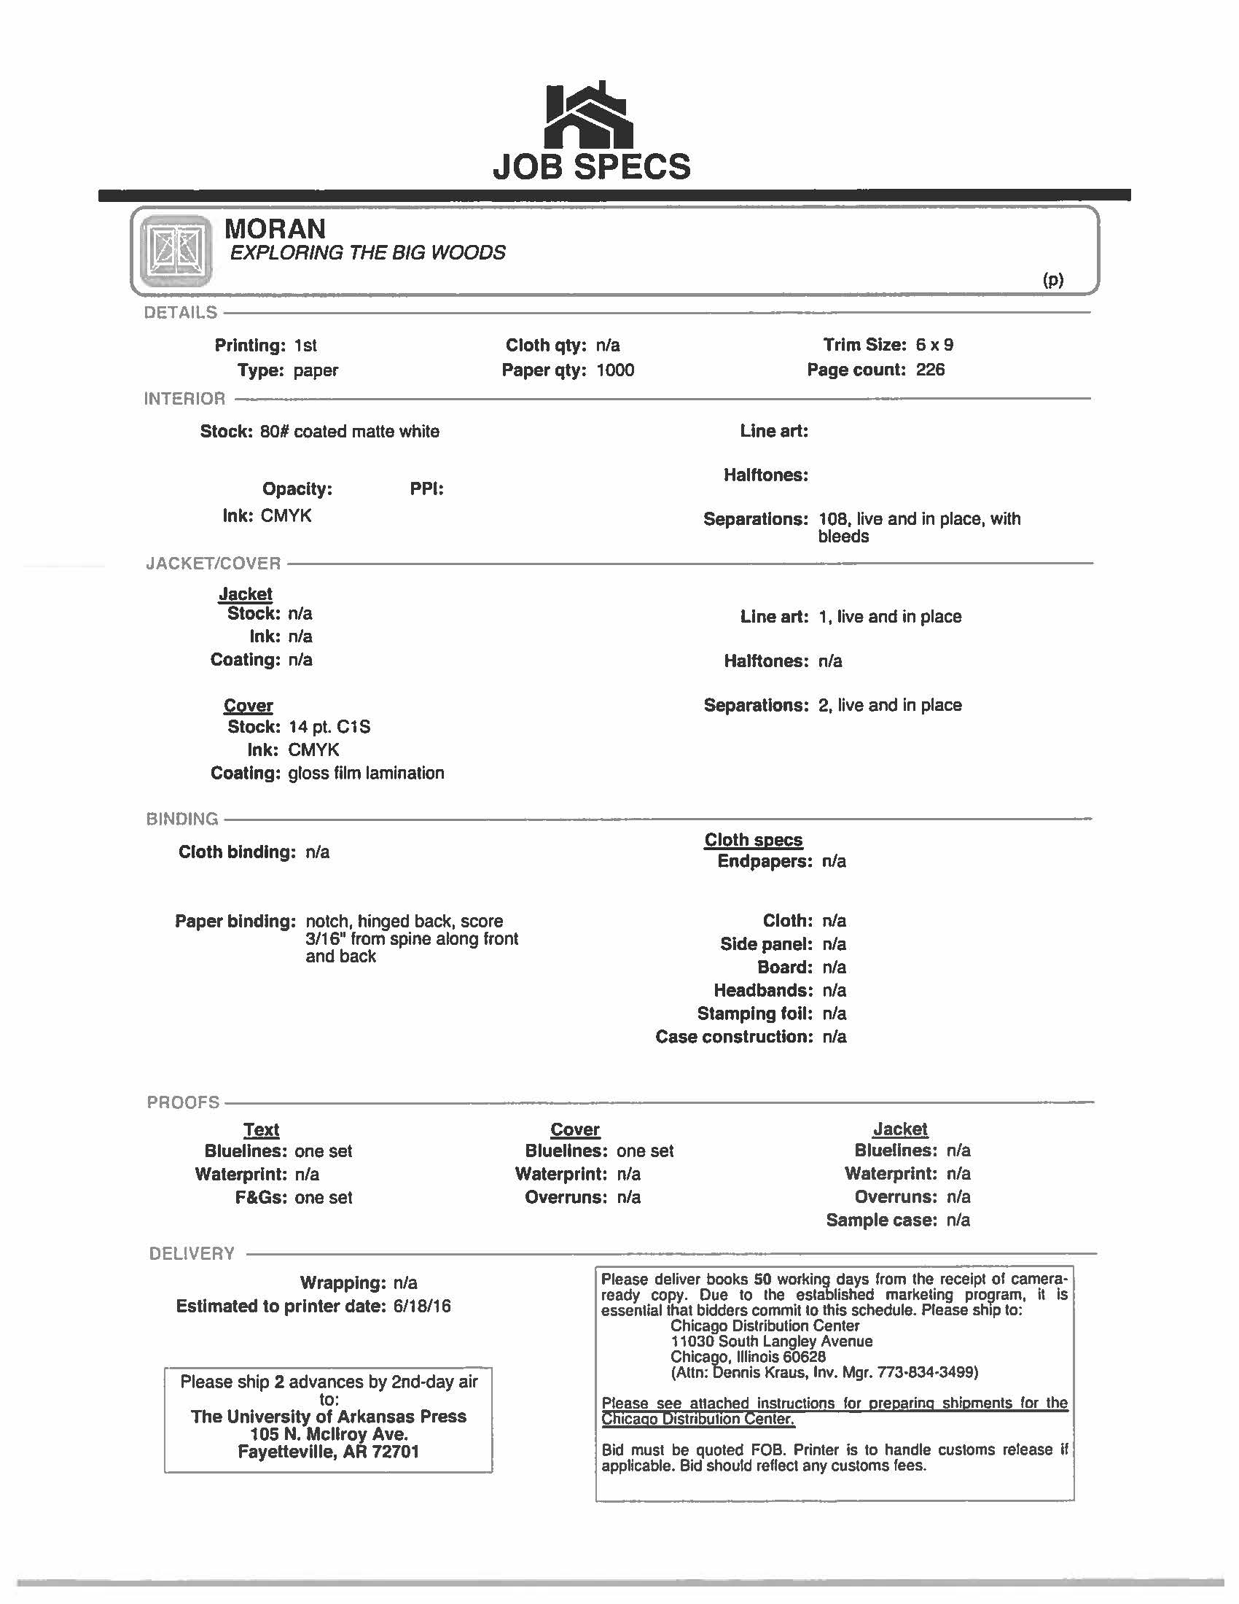

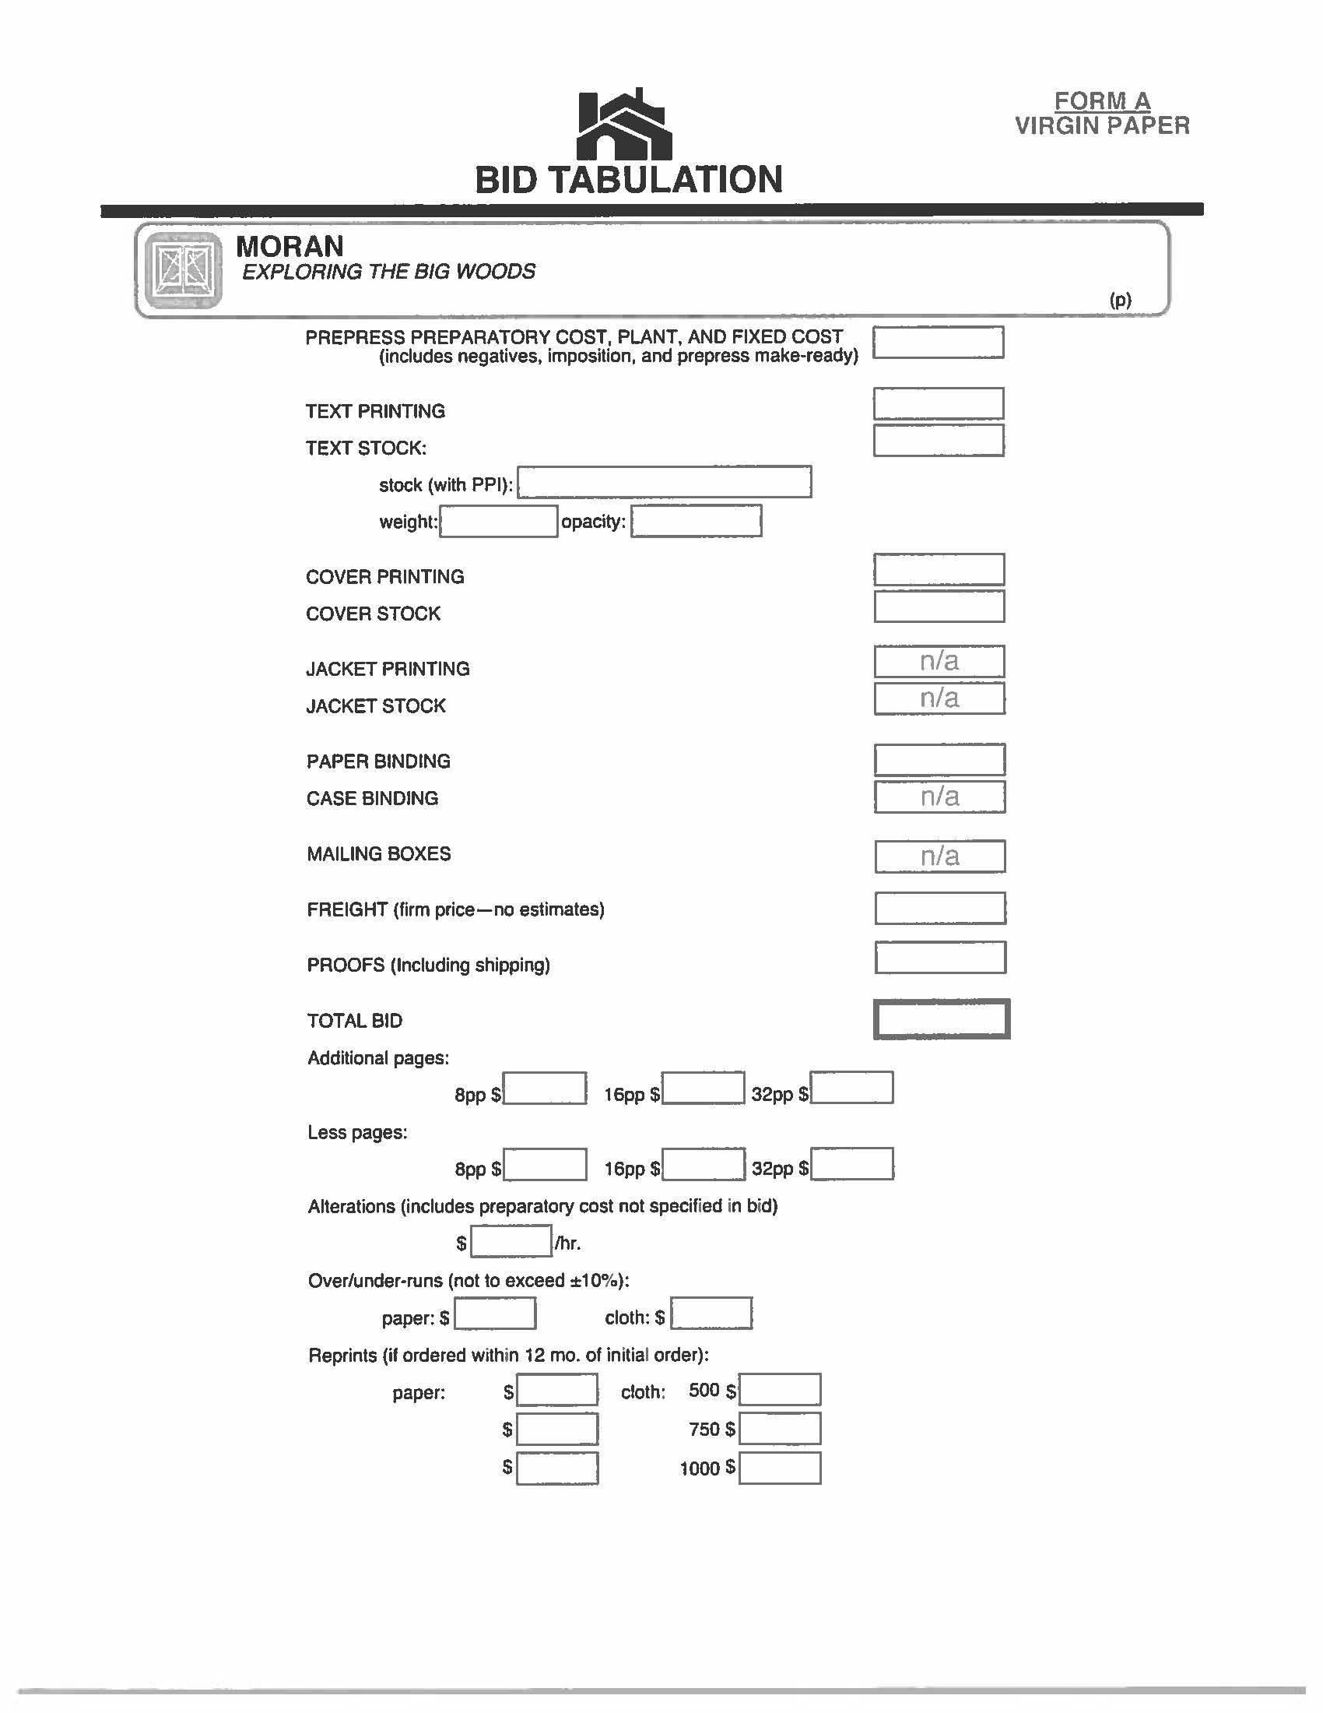
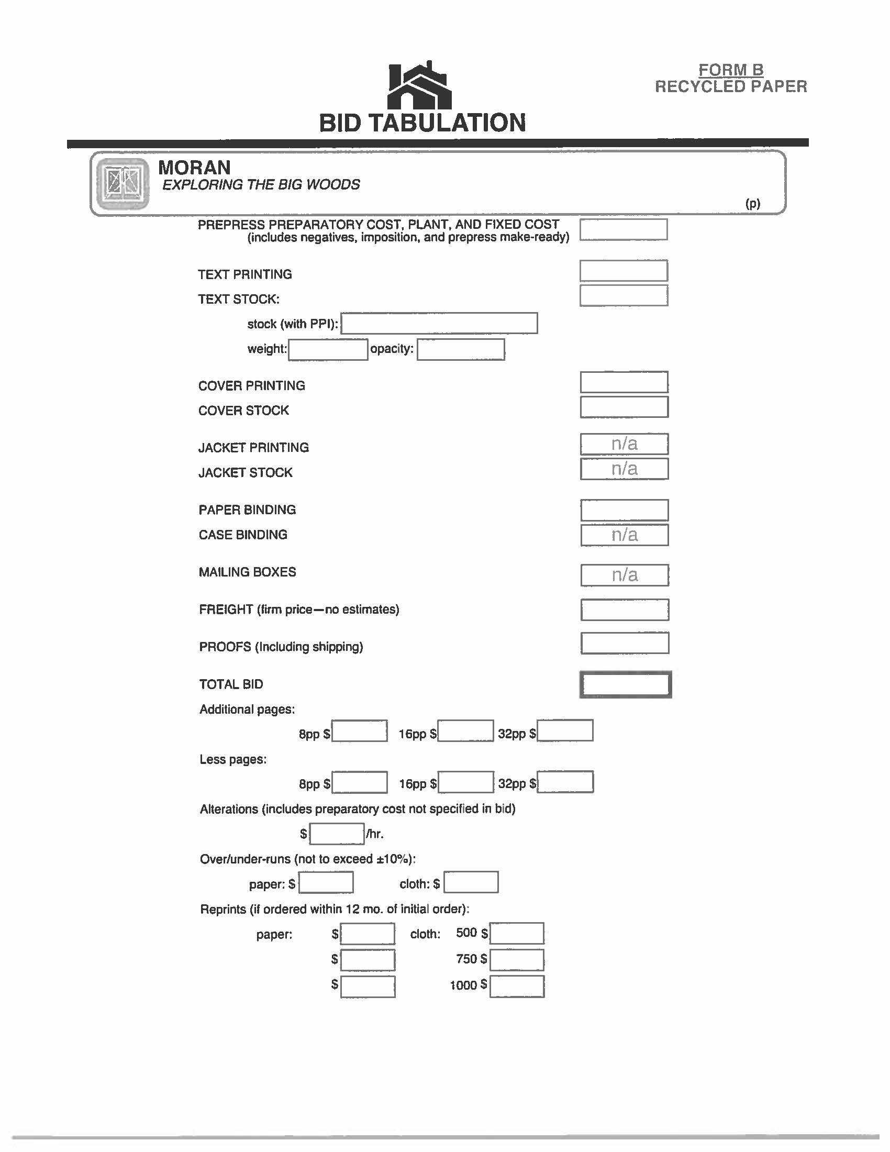
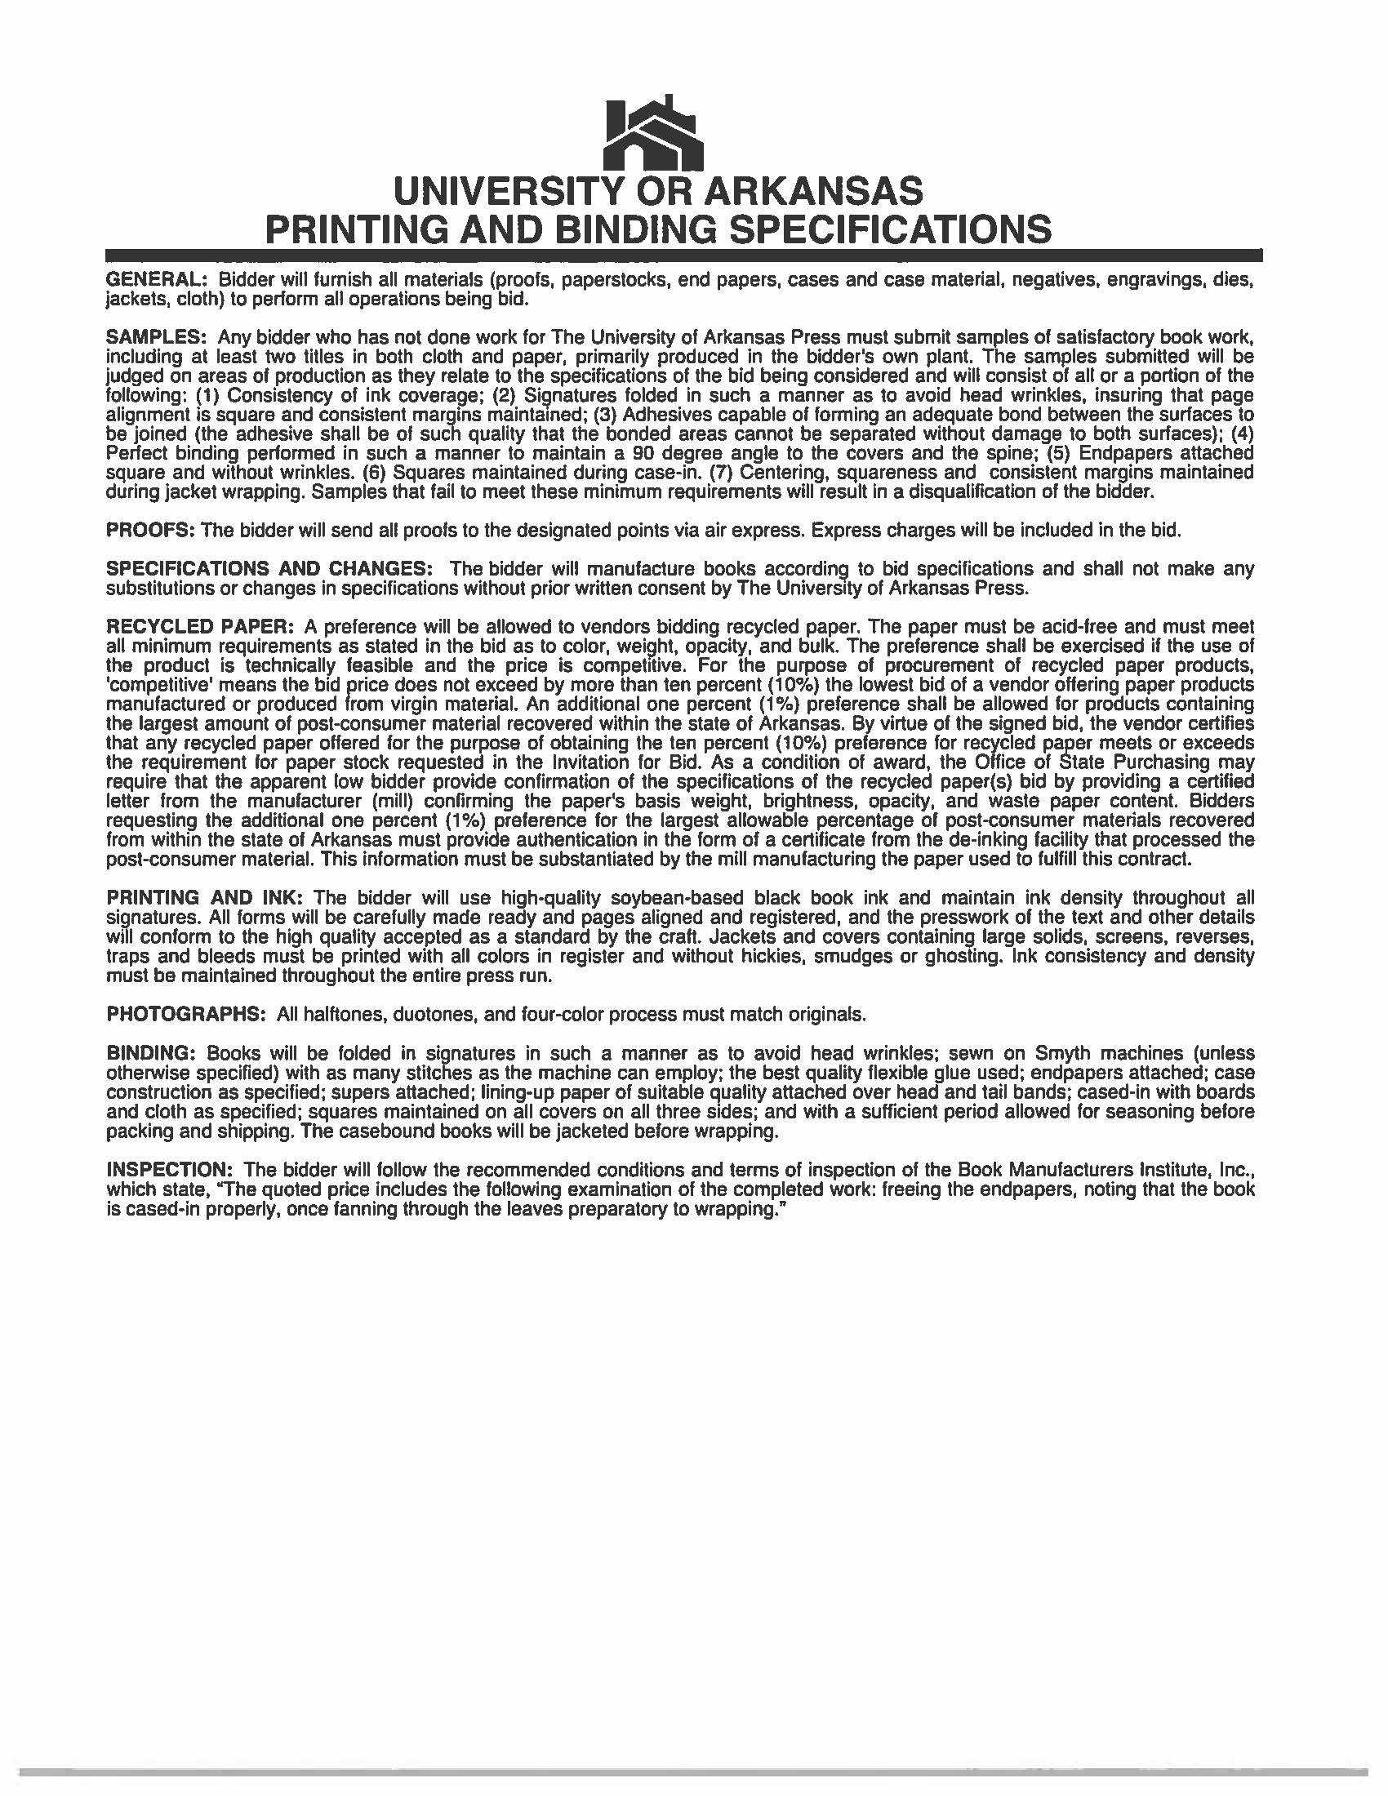
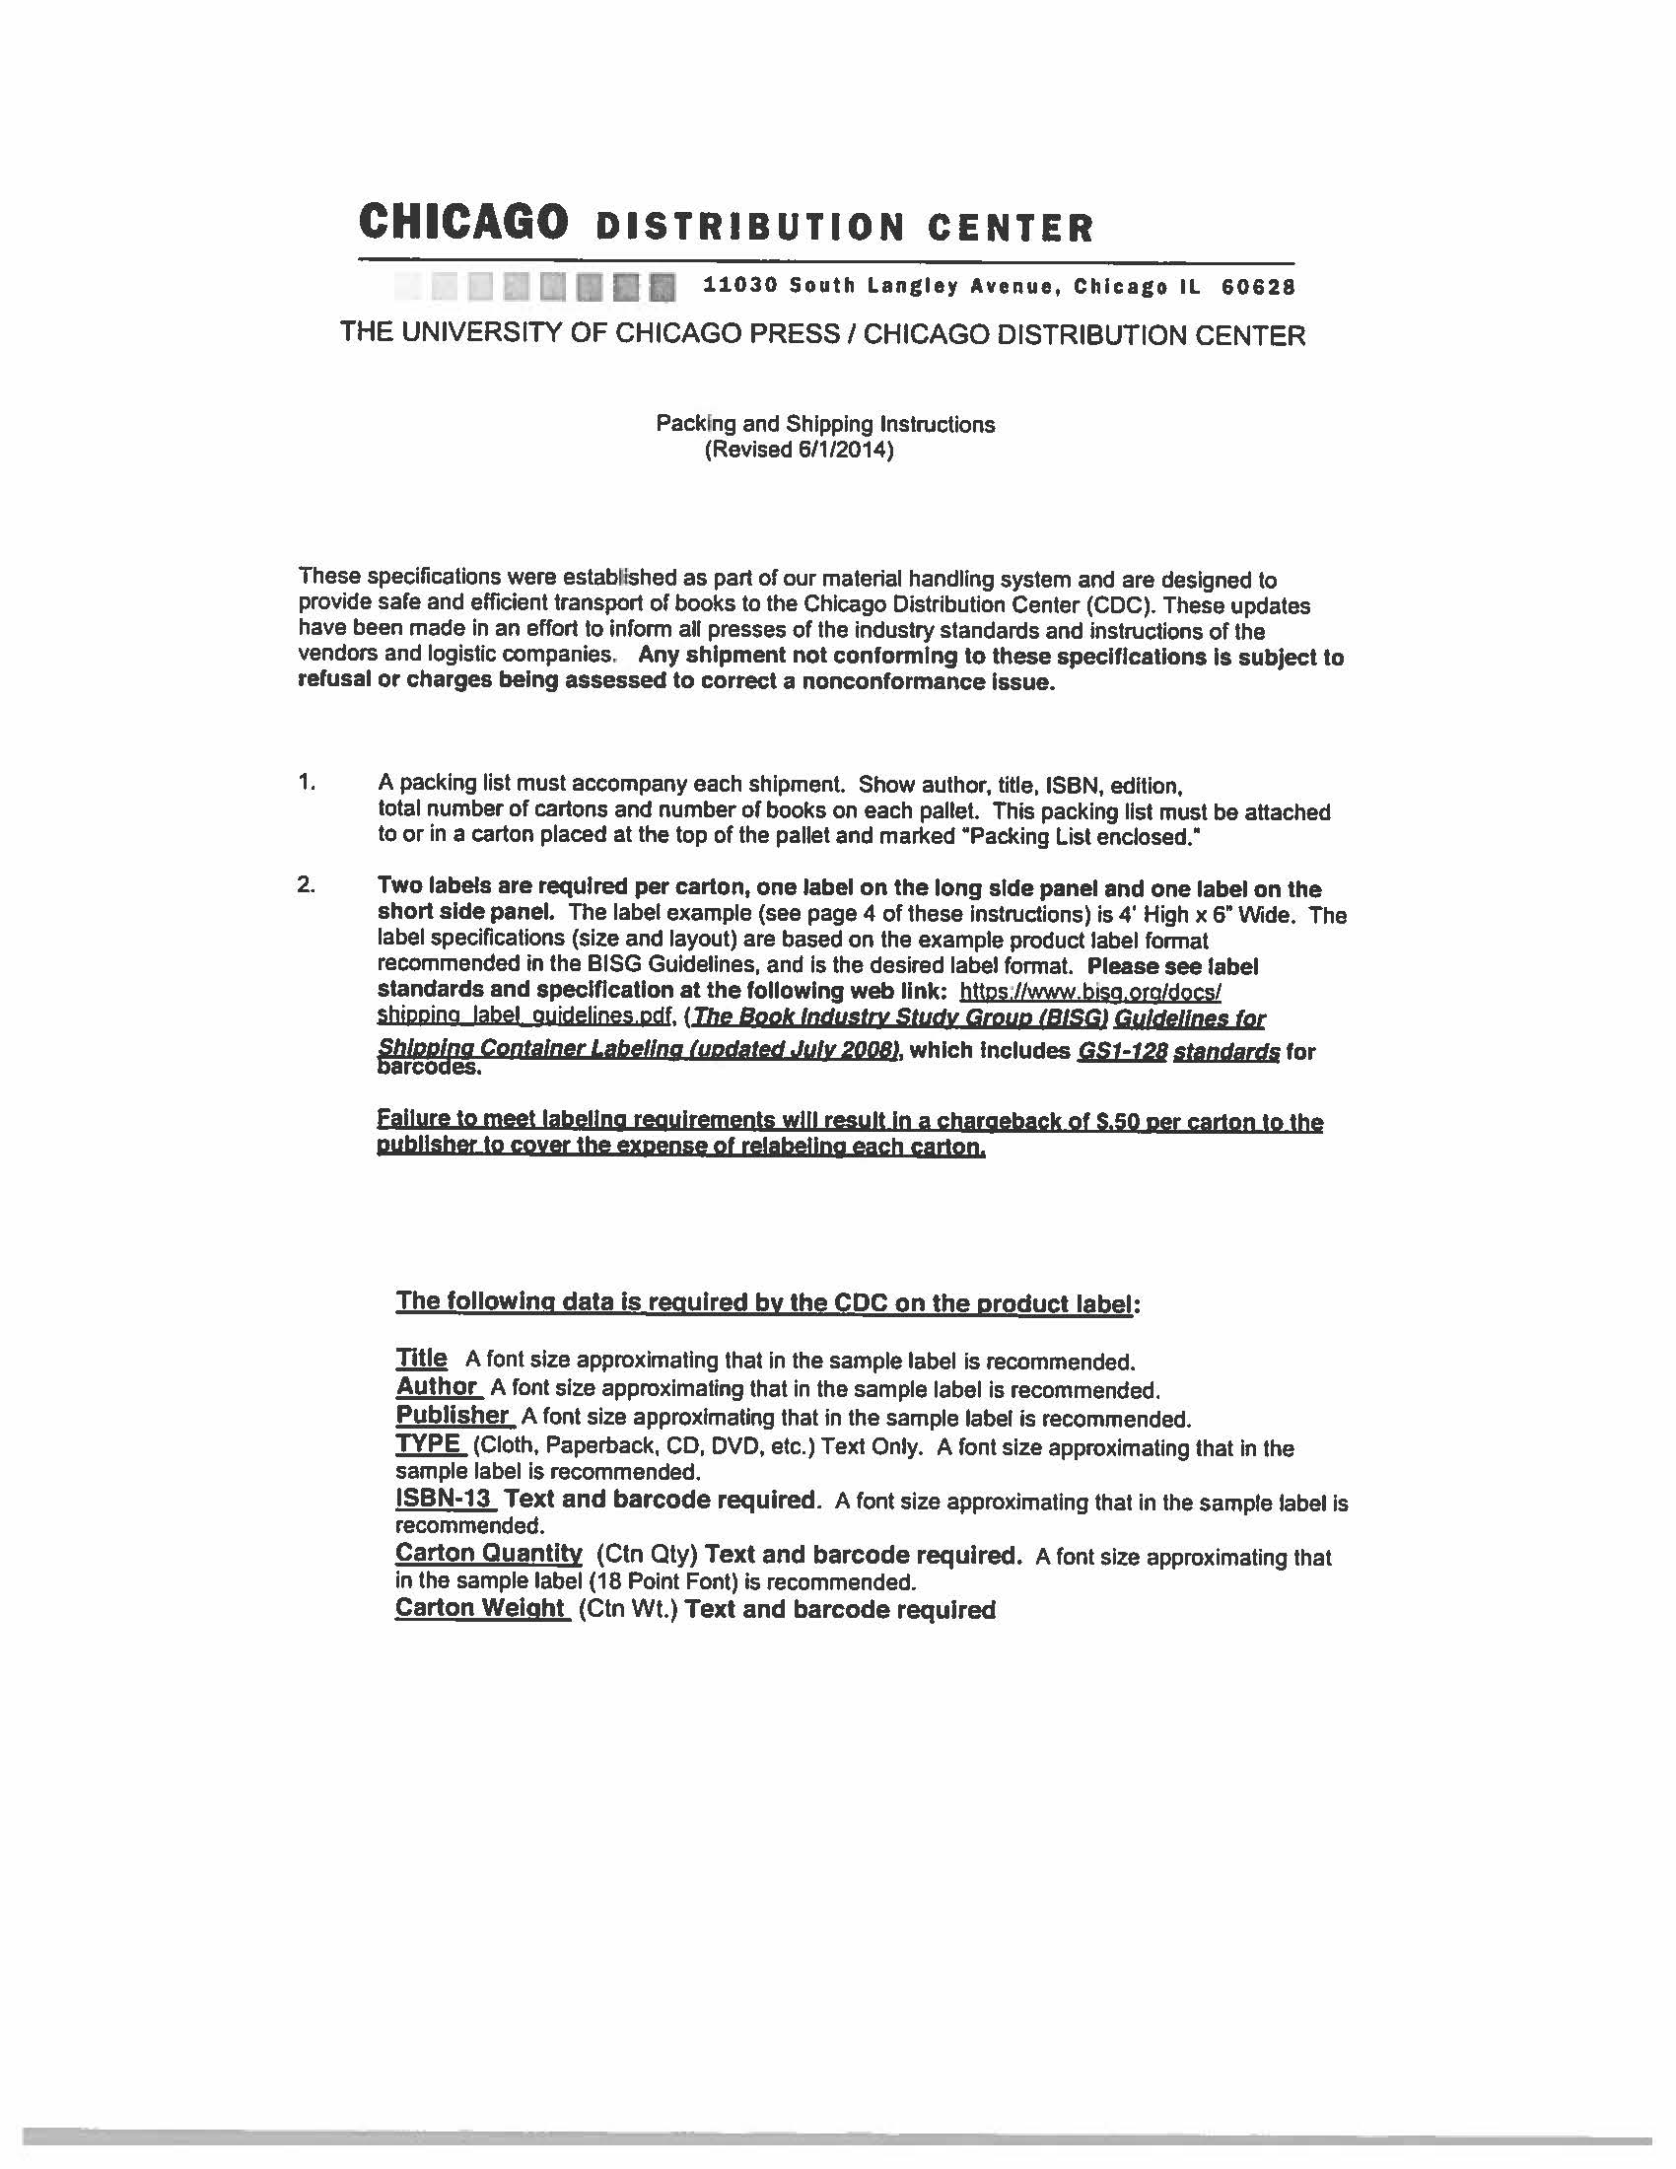
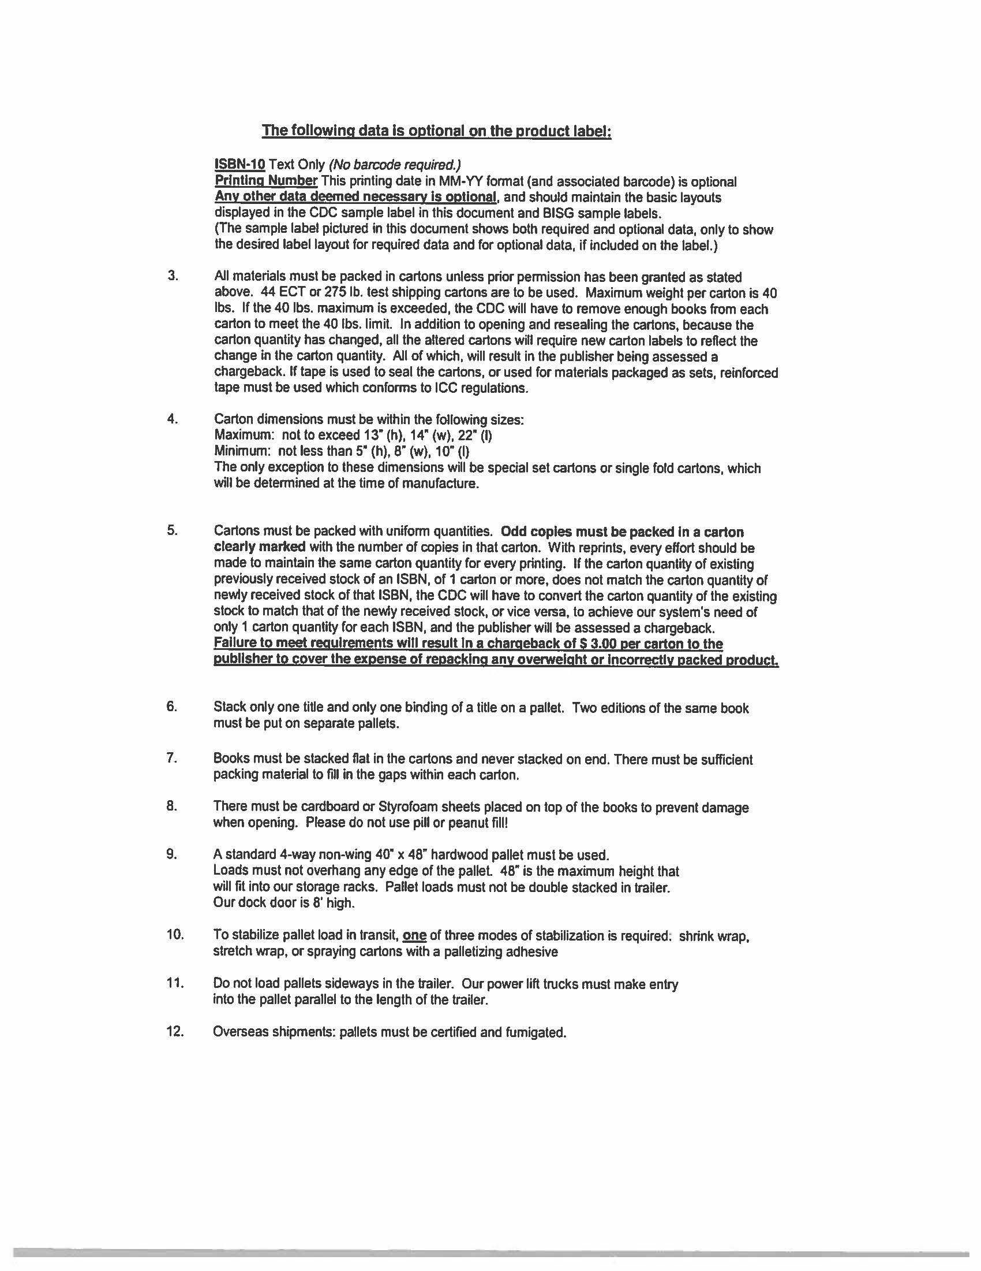
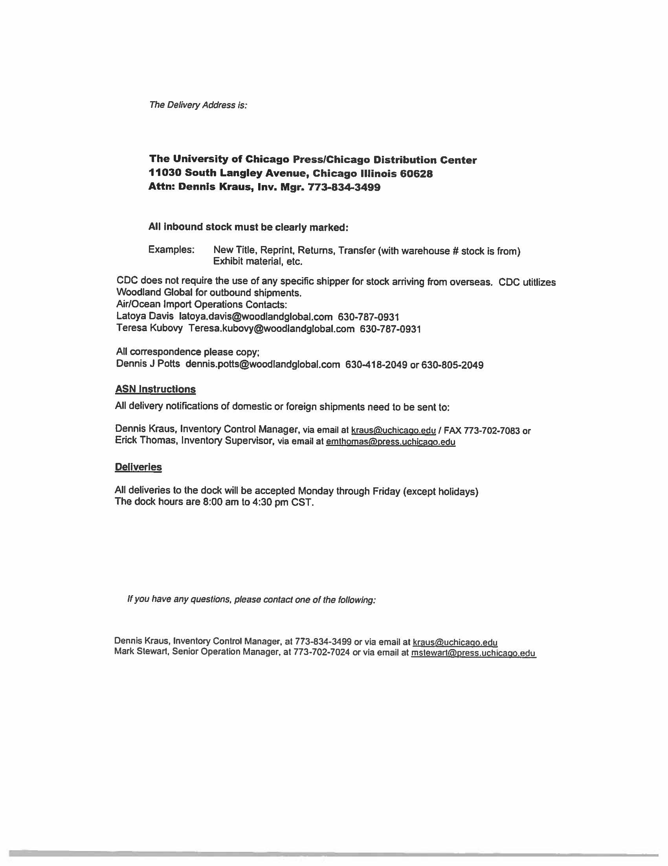
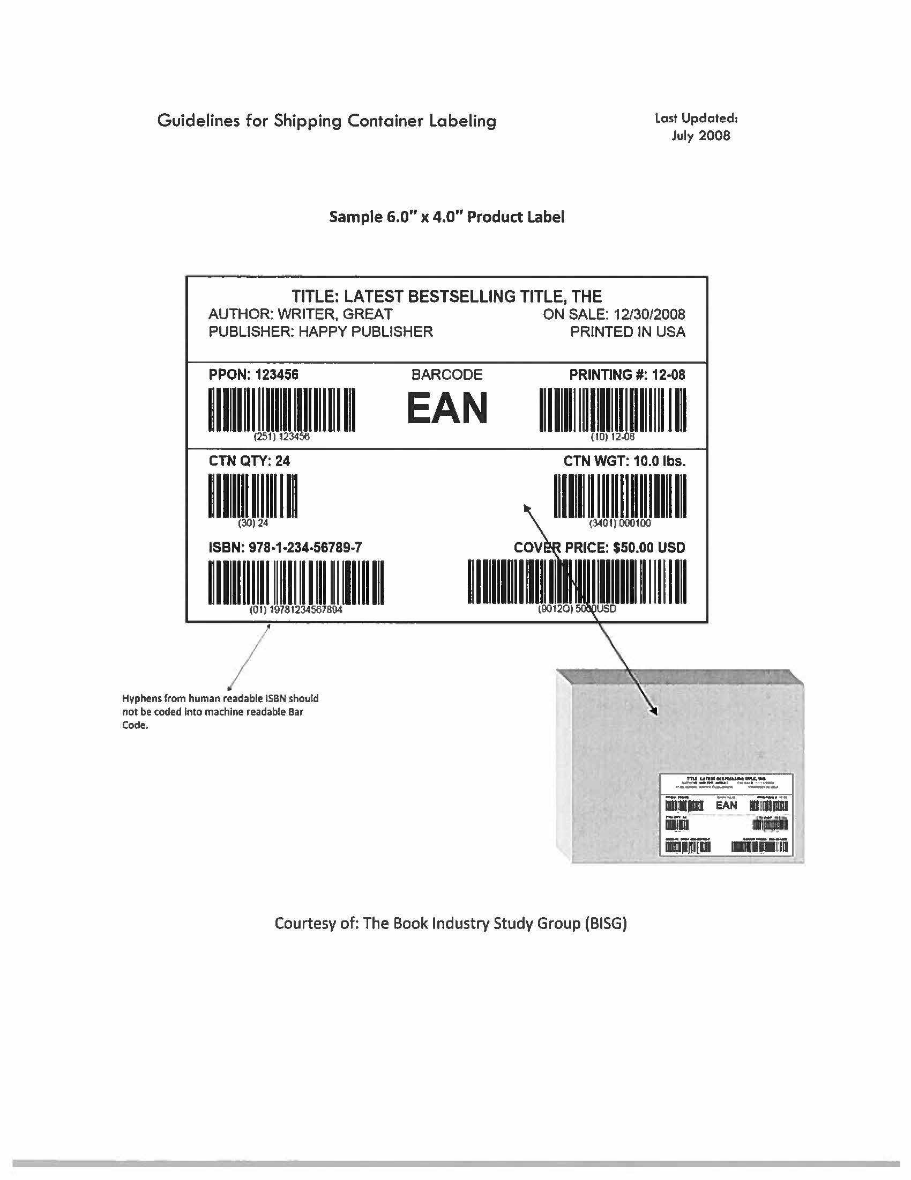
Equal Opportunity Policy Disclaimer

ATTENTION BIDDERS

Act 2157 of 2005 of the Arkansas Regular Legislative Session requires that any business or person bidding, who is responding to a formal bid request, Request for Proposal or Qualification, or negotiating a contract with the state for professional or consultant services, submit their most current equal opportunity policy (EO Policy).

Although bidders are encouraged to have a viable equal opportunity policy, a written response stating the bidder does not have such an EO Policy will be considered that bidder’s response and will be acceptable in complying with the requirement of Act 2157.

Submitting the EO Policy is a one-time requirement. The University of Arkansas, Fayetteville Procurement Department, will maintain a database of policies or written responses received from all bidders.

Note: This is a mandatory requirement when submitting an offer as described above.

Please complete and return this form with your bid response.

Should you have any questions regarding this requirement, please contact this office by calling (479) 575-2551.

Sincerely,

Linda K. Fast

Linda K. Fast, APO, CPPO, CPPB
Manager of Procurement Services
University of Arkansas
Fayetteville, AR

To be completed by business or person submitting response: (check appropriate box)

____ EO Policy Attached

____ EO Policy previously submitted to UA Purchasing Department

____ EO Policy is not available from business or person

Company Name
Or Individual: __________________________________________________________

Title: _____________________________________Date: ______________________

Signature: ____________________________________________________________

UNIVERSITY OF ARKANSAS
PROCUREMENT DEPARTMENT
1125 W. Maple ADMIN 321
Fayetteville, AR 72701
Tel: 479-575-2551
Fax: 479-575-4158

Act 157 of 2007 of the Arkansas Regular Legislative Session requires that any contractor, business or individual, having a public contract with a state agency for professional services, technical and general services, or any category of construction, in which the total dollar value of the contract is $25,000 or greater must certify, prior to the award of the contract, that they do not employ or contract with any illegal immigrants.

For purposes of this requirement, “Illegal immigrants” means any person not a citizen of the United States who has:

- Entered the United States in violation of the Federal Immigration and Naturalization Act or regulations issued the act;
- Legally entered but without the right to be employed in the United States; or
- Legally entered subject to a time limit but has remained illegally after expiration of the time limit.

This is a mandatory requirement. Failure to certify will result in our inability to issue a Purchase Order or Contract to you or your company.

Bidders shall certify online at http://www.arkansas.gov/dfa/procurement/pro_immigrant.html
Click on: “Procurement” on left-side information bar
Click on: Illegal Immigrant Reporting
Click on: “Vendor” Illegal Immigrant Contracting Disclosure Reporting Screen
Click on: “Vendor Submit Disclosure Form” to complete all fields required for the certification – then indicate below and sign this form to submit with your bid. ***NOTE*** Bid Number field is applicable if known.
REQUIRED: Print Screenshot and include with your proposal and/or contract.

If you have any questions, please call the UA Procurement Department at 479-575-2551.

Thank you.
Linda K. Fast
Linda K. Fast, APO, CPPO, CPPB
Manager of Procurement Services
University of Arkansas

**********************************************************************************************
TO BE COMPLETED BY BUSINESS OR PERSON SUBMITTING BID RESPONSE OR CONTRACT:

Please check the appropriate statement below:

_______ We certified that we are not an illegal immigrant
or do not employ or contract with any illegal immigrants.

Date of certification: ________________________

_______ We cannot so certify at this time, and we understand that
a contract cannot be awarded until we have done so.

Reason for non-certification: ______________________________

Name of Company: ___________________________________________

Signature: ___________________________________________

Name & Title: ___________________________________________
(Printed or typed)
Date: ___________________________________________




