321 Administration Building, Fayetteville, Arkansas 72701
Phone: 479.575.2551 Fax: 479.575.4158

March 24, 2016

RE: Recommendation of Award – RFP 590105 Communication/Marketing Services Term Contract

To All Respondents:

This is formal notification that the University of Arkansas has received the official recommendation for award from the evaluation committee selected to review the proposals for RFP R590105 Communications/Marketing Services Term Contract. The recommendation of the term contract award extends to Educational Marketing Group.

Respectfully, this letter of “Intent to Award” serves as notification that contract negotiations will commence with the successful vendor(s) with the ultimate goal of a Purchase Order/term contract to be issued by the University of Arkansas to Educational Marketing Group.

The bid award/term contract will be March 24, 2016 to March 23, 2017. Thereafter, the contract may be renewed upon mutual agreement of both parties for a period of additional years not to exceed seven (7) years unless terminated sooner.
We encourage and appreciate the participation of our vendor community. If you have any questions regarding this award, please do not hesitate to email me.

Sincerely,
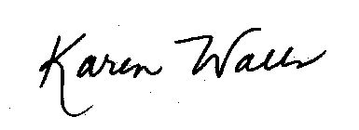
Karen A. \Walls, CPPB
Buyer
University of Arkansas
E-mail: kwalls@uark.edu
Phone: 479.575.6400
Fax: 479.575.4158

